**Futsal Management System**



Uttam Tamang

00172895

Computing Project

Level 5 Diploma in Computing

Softwarica College of IT and E-Commerce

Kathmandu, Nepal

04/01/2019

**Abstract**

Futsal Management System that I have developed is a web-based application that can be used for booking ground in any futsal. System is Client Server Architecture based, developed using LARAVEL Framework based upon PHP language and it is fully dynamic and user-friendly UI design.

The primary aim for developing this solution as replacement of traditional booking system, which is mostly phone based or physical presence of client by them self. Which results in having use of extra human resource and time and cost. Similarly, not having dynamic system for booking process lacks in facilities such as 24/7 available booking system. Likewise, even in booking hour sometime due to network error and unavailability of staff member in time had results in compromising booking process and customer satisfaction.

So that, Futsal Management Syatem is brought as solution for such problem, with aim of providing availability of booking system 24/7 and high accuracy and reliable system. FMS is website and allows clients to book interested ground online and from any place any time.

**Acknowledgement**

This space is insufficient to thank all the people who have help and support for this project, Futsal Field Management and Reservation System. I want to thank everybody for the great support and belief shown towards me.

I respect and thank **Mr. Kiran Rana** for giving me an opportunity to do the project in Futsal Management system and providing guidance, which made me complete the project else this project would never been completed in time. He helped me a lot and supported me and gave me an encouragement for my project.

I would also like to thank all my colleague who had helped me during my project time by sharing their knowledge, idea, feelings and their opinion.

Last but not the least, I am equally indebted to my friends and my teachers from **Softwarica College of IT & E-Commerce** who never stopped believing on me.

Table of Contents

**Chapter 1** 6

Introduction 6

Background of the project 6

Problem Statement 6

Aim and Objectives 7

Scope and Limitation 7

Scope 7

Limitation 7

Feature of the project 7

**Chapter 2** 9

Analysis 9

Requirement Analysis 9

Use Case Diagram 9

Architecture Diagram 11

1. Initial Class Diagram 11

Class Notation 11

Purpose of Class Diagrams 11

System Architecture 12

**Chapter 3** 14

Design 14

Structural Model 14

1. Final Class Diagram 14

Behavioral Model 15

1. Activity Diagram 15

2. Sequence Diagram 19

Database Design 21

UI Modelling Prototype 22

UI Design 27

**Chapter 4** 24

Implementation 24

Language (PHP) 24

Framework (Laravel) 24

Development Methodology 24

Design Pattern 26

**Chapter 5** 27

Testing 30

1. Unit Testing 30

2. Black Box Testing 31

**Chapter 6** 41

Other Project Issues 41

Risk Management 41

Work Breakdown Structure 42

Configuration Management 42

**Chapter 7** 44

Conclusion 44

**Chapter 8** 44

References 44

**Chapter 9** 45

Appendix 45

# **Chapter 1**

# Introduction

Project that I had currently developed falls under L5DC’s Module Computing Project. Aim of this project was to reflect student’s learning over their three semester of study (L4DC and 1st semester of L5DC) and preparing them for real world project in their respective field of interest.

In modern days, sport is considered as most important source of entertainment and encourage for healthy lifestyle and physical fitness. In which, Football is most popular sport among them as it attracts people of any group of people such as teenagers, adults, kids as well as working(job) people. Futsal is smaller and indoor football-based game which helps in providing football experience mainly for smaller number of players.

Futsal Management System is the project that I had developed and it is web-based application. The system is all about keeping record of information about clients and their reservation or booking information. Information will be recorded in such a way that it will provide data availability and prevention from data duplication, thus providing systematic management of business process.

# Problem Background to the system

Until now, futsal organization is fully dependent upon general visit to management office and filling paper-based documentation or unnecessary amount of phone call for placing booking their booking to particular ground on particular time frame. The main problem with this system is that it is complex and time consuming for both management staff and client.

Consequently, booking process is not always easy for clients. Specially, doesn’t allows them to place their booking from anywhere and whenever they want. Because, if they want a reservation, they are forced to be visit in registration office and if they are known clients even then they have to make phone calls to place bookings which will never sure for correct and effective booking.

So, mission of project has been to providing features which will minimize or completely remove these problems and maintain a healthy relationship among business process and clients.

# Justification

At present, people are very busy with their works, jobs, studies and many other stuffs. So, time is most important aspect of life. However, technology had been growing in similar or even faster rate and making our life to be easier and comfortable as possible. Online shopping, marketing, working, any many more facilities are best example of how technology had made things easier now a days. Likewise, project futsal management system is also a web based solution offering solution of booking futsal ground online via internet in an effective way.

FMS provides secure and reliable solution as it is protected with authentication facility. So, only valid user can get access in booking process of the system. Which can be done with registration and login process. Also, it has seperate admin (type of user) dash board where they have permit to perform management process of the system, including client’s booking records, grounds management and rates and time management. Similarly, system support modern record keeping system (database), which will provide greater security, reliability, availability of information and easy maintenance, storing and retrieving facilities.

# Overview of the project design

Application is secure, reliable and packed with easy and user-friendly UI Design. First of all, system had own home page where customer is allowed to visit there and get information of organization. And navigation panel will allow to make registration of new client, Login system and dashboards etc. Similarly, admins can access to admin dashboard where they are allowed to make management process from there. And all authentication system is there in order to allow valid user to be authenticate and place accurate reservations.

# Aim and Objectives

**Following are the Aim and Objectives of project:**

**Aim**

* Easy booking process
* To maintain customer as well as employee Satisfaction.
* Promote sport and healthy environment in society.
* Maintaining Reports

**Objectives**

* Firstly, all reservation system will made online as well as done from registration office.
* Reduce every possible manual task with automation system. Such as modern Database System
* User friendly UI design.
* Reliable and secure record system.
* Providing well facilitated sport ground at possible lower cost.
* Keeping record of user feedbacks and necessary Improvements.

# Scope and Limitation

## Scope

As per problem statement of project, scope of project is providing functionality that meets requirements specified at problem statement. Which includes mainly about replacing manual task with automated system or other simpler ways. For example, storing record of client’s information with form filling at registration office with physical visit should replace with web-based registration from anywhere user wants. Similarly, good UI design, easy ground reservation, accept and rejection of reservation made and automatic reservation removing functionality as per rules and policy are scope of the project.

## Limitation

Current project in developed with such vision that it will manage reservation and record keeping/tracking functionalities. However, projects lack upon accepting online payment system. Which requires clients for short visit in office for payment of their reservation.

# Feature of the project

Features of the project includes:

* User registration and login
  + System user can register them self with personal information in system and then they will be provided system access service for making reservation.
  + User can be system admins as well and Clients/Customers.
* Check available timeslots
  + Clients that wants to make reservation will be provided with list of available timeslots for ground reservation.
  + Reserved timeslots will be displayed as “Booked timeslot’ and restrict from making booking in that time.

* Check respective cost according to time
  + As cost for the ground can be varies according to time. Clients will be informed with cost for that perticular timeframe.
* Place booking (Client/Admins)
  + It’s a primary goal of system in which client who had login to system can make reservation for ground at available time.
* Display their booking and change status to booking or paid
  + In admin dashboard, admin will be presented with list of reservation that have been made by every client.
* Manage personal information’s
  + System will have service for updating personal information.
  + For example, changing name, phone number, address etc.
* Grounds and Rate Add/Update/Delete
* Admin are allowed to insert update and delete grounds and their rate information of respective organization.

# **Chapter 2**

# Analysis

In Software development life cycle (SDLC) Analysis is very first and most important part of software development. This is the phase where studying and identifying all possible requirements of the system gets captured. And then prioritization of those requirements is finalized. Hence, it makes in clarification of aim and objectives of the system and provides easy, efficient and effective way of achieving the solution.

In other way, it can be described as technique which helps in identification of possible requirements of the system and provides bigger picture of how system should work and guideline for the developers, how to meet those requirements in an easier way. It is also useful for tackling issues that may comes in development phase and allows to having a proper solution for that which comes in handy for future development. (Anon., 2015)

**Object Oriented Analysis**

OOA is a modern analysis methodology and it is a phase where requirements of the system get identified as well as classes and relationships between classes gets identified. In other words, object-oriented analysis is the analysis technique that aims to model a functional requirement of the system ignoring potential implementation requirements. It focusses with objects and interaction between them and combine all behaviors, characteristics and states together and analyze them and construct accurate object model for the system.

Pitfalls and merits of Futsal Management System

Merits of the system are:

* System is web based (online) solution so customer can place their bookings from anywhere and also anytime.
* System offers security features via authentication system.
* UI design of system is clean, sleek and easy to navigate and offers greater scalability.

Pitfalls of the system are:

* Online payment system is unavailable.
* Online Customer Care Service is unavailable

## Requirement Analysis

There are two types of requirements, they are:

1. Functional Requirements
2. Non-Functional Requirements

**Functional Requirements**

Functional requirements are those requirements which describes a behavior of features, function of the system when certain conditions are meet. Typically, functional requirements specify what a system should do to accomplish requirement specifications and user expectations.

**Non-Functional Requirements**

Non-functional requirements are those requirements which describes how the system performs a certain function in order to accomplish requirement specifications and user expectations. They describe the systems attributes or characteristics of the system. Reliability, security, performance, User experience are example of non-functional requirements of the system.

**Prioritization of Requirements**

Prioritization of Requirements refers to method of placing features or requirements of the system in an order of their importance to the system. Prioritization of requirement is very important tools for giving extra push in system development as it allows developer to understand requirements in a better way and what should accomplish first and move to next one. I have used **MoSCoW prioritization** methodology to prioritize requirements of FMS, as it is simple and easy to understand. MoSCoW stands for Most have, Should have, Could have and Wont have feature or requirements of the system. (Anon., 2018)

**Must Have**

* It specifies critical requirements that must be present in the system.
* 60% of requirements are covered in must have list.

Should Have

* These requirements hold important value in system but not as importance as must have requirements.
* 20% of requirements are covered in should have list.

Could have

* These requirements are quite essential but not that much of important to system to run. They are like additional client’s wished requirements for their benefit.
* 20% of requirements are covered in could have list.

Won’t have

* Those requirements that holds near very low values in system or requirements which are not complete in time frame but may be include in future are won’t have requirements.

**Functional Requirements and their Prioritization of FMS are:**

|  |  |  |  |
| --- | --- | --- | --- |
| **FN_ID** | **Requirements** | **MoSCoW** | **Dependency** |
| F1 | User Registration | Must have |  |
| F2 | Login System (Client/Admin) | Must have | F1 |
| F3 | Profile Update | Should have | F1 F2 |
| F4 | View User Information | Should have | F1, F2 |
| F5 | Ground Insert | Must have | F2 |
| F6 | Ground Update | Must have | F2, F5 |
| F7 | Ground Delete | Must have | F2, F5 |
| F8 | Rate Time Insert | Must have | F2 |
| F9 | Rate Time Update | Must have | F2, F8 |
| F10 | Rate Time Delete | Must have | F2, F8 |
| F11 | Display Available booking Timeslots | Must have | F2 |
| F12 | Add Bookings | Must have | F2 |
| F13 | View Bookings | Must have | F2, F12 |
| F14 | Cancel Bookings | Must have | F2, F12 |
| F15 | Prevent Booking Duplication | Must have | F12 |
| F16 | Online Customer Care | Could Have |  |
| F17 | Billing System | Should Have | F12 |
| F18 | User Manual | Should have |  |
| F19 | Accessibility Function | Could have |  |

**Non-Functional Requirements of FMS are:**

|  |  |  |
| --- | --- | --- |
| **NF_ID** | **Requirements** | **Description** |
| NF1 | User Friendly UI | System should offer Easy to navigate UI design, so that everyone could use it without any problem. |
| NF2 | Security | System should support security measures to prevent from un-authorized users and gain permission over system database. |
| NF3 | Reliability and accuracy | System should be reliable and accurate so that trust can be built with client. |
| NF4 | Performance | System should be as fast and responsive as possible so that user can use it without hesitation. |
| NF5 | Scalable | System should be able to use with any devices, browser, OS as possible. |
| NF6 | Maintainable | System is supposed to be easily maintainable so that whenever it requires to be fixing/updating it should be done in lower timeframe. |

**Natural Language Analysis (NLA)**

NLA is a very useful tools that helps in identification of list of candidate classes, along with relationships and respective attributes from descriptive text. Process includes identification of Nouns, Verbs and adjectives in piece of text, and noun refers to potential classes, verbs refers to potential methods and adjectives refers to potential attributes of that class.

After having list, they are further proceeded into filtration steps where we get advanced list of candidate classes.

**Filtration steps includes:**

* Duplication and Irrelevancies gets removed.
* Words that have higher level of abstraction gets removed.
* Words that are part of system gets removed.
* Words having outside of scope gets removed.

List of candidate classes, attributes and methods I got was:

|  |  |  |  |
| --- | --- | --- | --- |
| SN | Class name | attributes | methods |
| 1 | User | Name, Address, Phone, Gender, Age, email | Register, Update Profile, Delete_user |
| 2 | Admin | Name, Address, Phone, Gender, Age, email | Register, Update_Admin, Delete_Admin |
| 3 | Bookings | Ground, Date, Time, User_id | AddBookings, cancelBookings |
| 4 | Ground | Ground Name, description | AddGround, DeleteGround, UpdateGround |
| 5 | Rates | Rate, Ground_id | AddRate, editRate, deleteRate |
| 6 | Times | Time, Ground_id | addTimes, editTimes, deleteTimes |

## Use Case Diagram

A use case is a powerful yet low cost and time saving system analysis methodology which helps to identify, simplify, and gather system’s each major requirement. Use case diagram is constructed with help of number of related sequences of interactions with system and **actors** in order to achieve perticular aim. That’s why it contains all system activities that is related to users.

Characteristics of use case diagram are:

* Use case diagrams do not display interactions between actor with actors.
* Stick figure is used to signify actors.
* Actions are characterised as ovals in which a broad description of the process is placed.
* A specific interaction is defined as a line which connects the actor and the action they can perform.

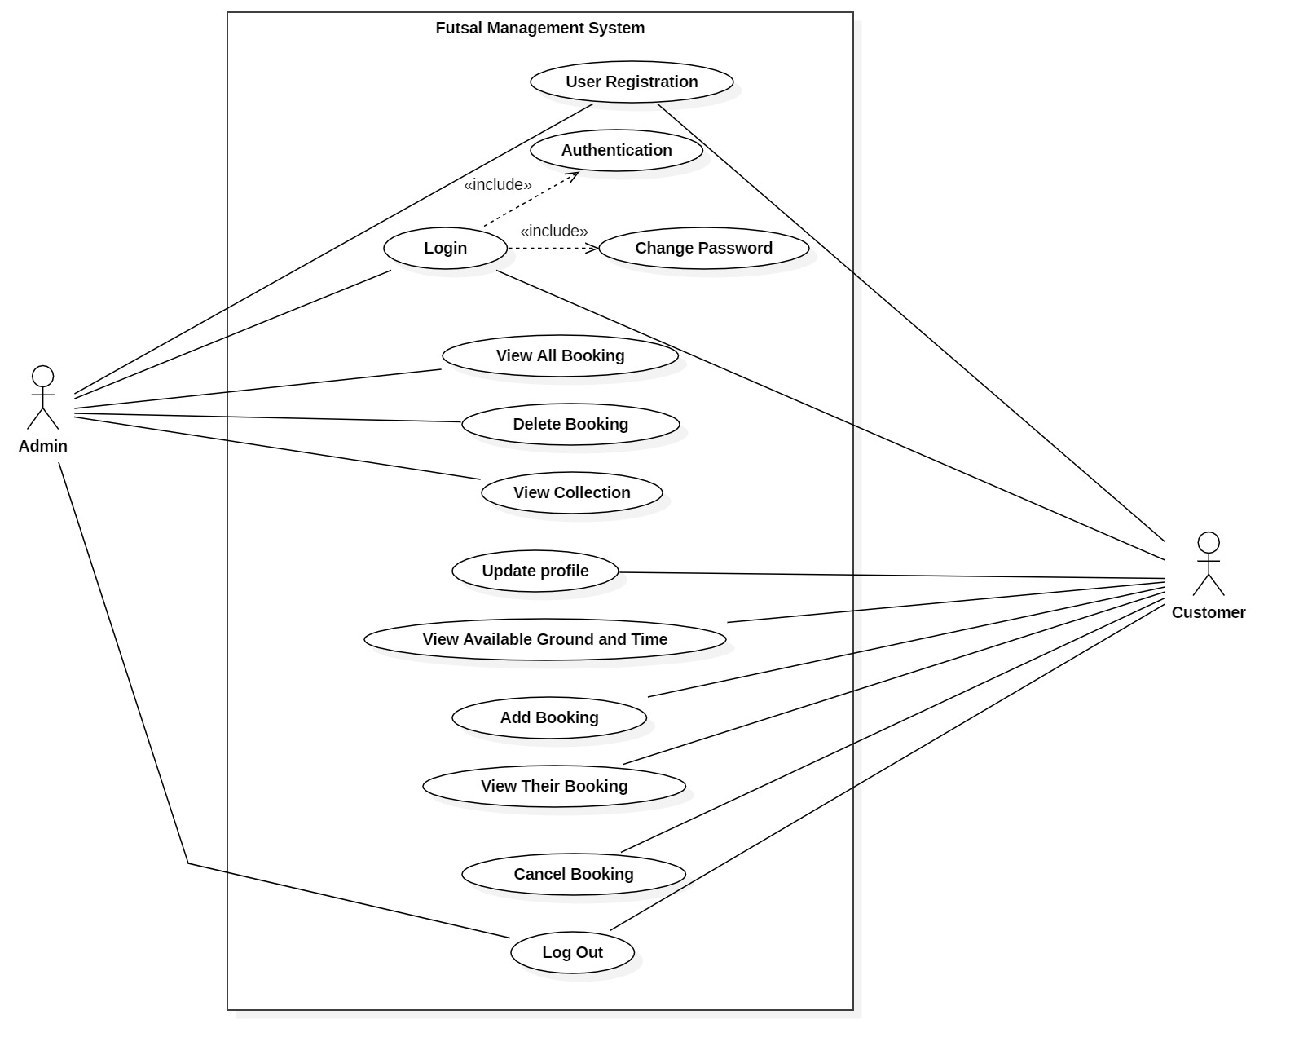

## Architecture Diagram

## Initial Class Diagram

**Class**

A blueprint of objects having same roles in the system, which can be explains as having same attributes and operations.

* Attributes (Structural features)
  + Represent the state of an object of the class
  + Are descriptions of the structural or static features of a class
* Operations (Behavioral features)
  + define what objects of the class "can do"
  + Operations are descriptions of behavioral or dynamic features of a class

Class Notation

A class notation consists of three parts:

1. Class Name
   * The name of the class appears in the first partition.
2. Attributes
   * Attributes are shown in the second partition.
   * The attribute type is shown after the colon.
   * Attributes map onto member variables (data members) in code.
3. Operations (Methods)
   * Operations are shown in the third partition. They are servicing the class provides.
   * The return type of a method is shown after the colon at the end of the method signature.
   * The return type of method parameters are shown after the colon following the parameter name.
   * Operations map onto class methods in code

**Class Diagram**

A class diagram in the Unified Modelling Language (UML) is **a type of static structure diagram** that describes the structure of a system by showing the system's classes, their attributes, operations (or methods), and the relationships among objects.

Purpose of Class Diagrams

* It is used to represent static structure of the system.
* It helps in understanding of system for developer teams and related members
* Business Analysts can use class diagrams to model systems from business perspective

**Initial Class Diagram**

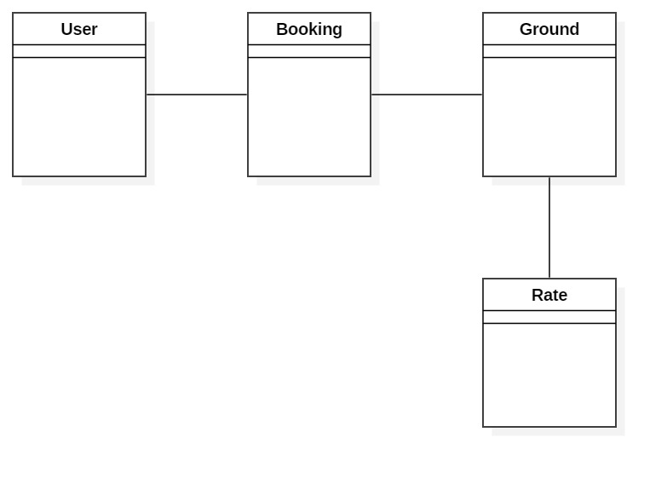

# System Architecture

Conceptual model that represents structure, behavior and view of your system is known as system architecture. It is combination of system components and established subsystem together to construct complete system.

In this project I have used 3-tire system architecture which is also commonly known as Client-Server architecture in this architecture functional process logic, data access, data recording system and UI design are developed and maintained as independent modules on separate platform. (Anon., 2018)

**Three layers of 3-tier architecture are:**

* **Presentation layer**

Displays view of your system i.e. UI. It sends contents to browser in form of HTML/CSS/JS.

* **Application layer**

Application server is used and processes business logic for an application.

* **Data layer**

It is simply Database management system, which lets you access over application data.

**Diagrammatic representation of 3-tire system architecture is:**

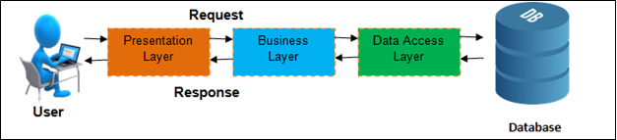

Figure 3 3-Tier Architecture

**Why 3-tire over 2-tire system architecture?**

2-tier architecture involves direct interaction between client with server but 3-tire includes business layer in between client and server thus maintaining extra layer of security. The reason behind choosing 3-tire system architecture over 2-tire system architecture is because, 3-tire architecture provides greater scalability and data security. And client data availability is very important in present technology.

# **Chapter 3**

# Design

# Structural Model

## Final Class Diagram

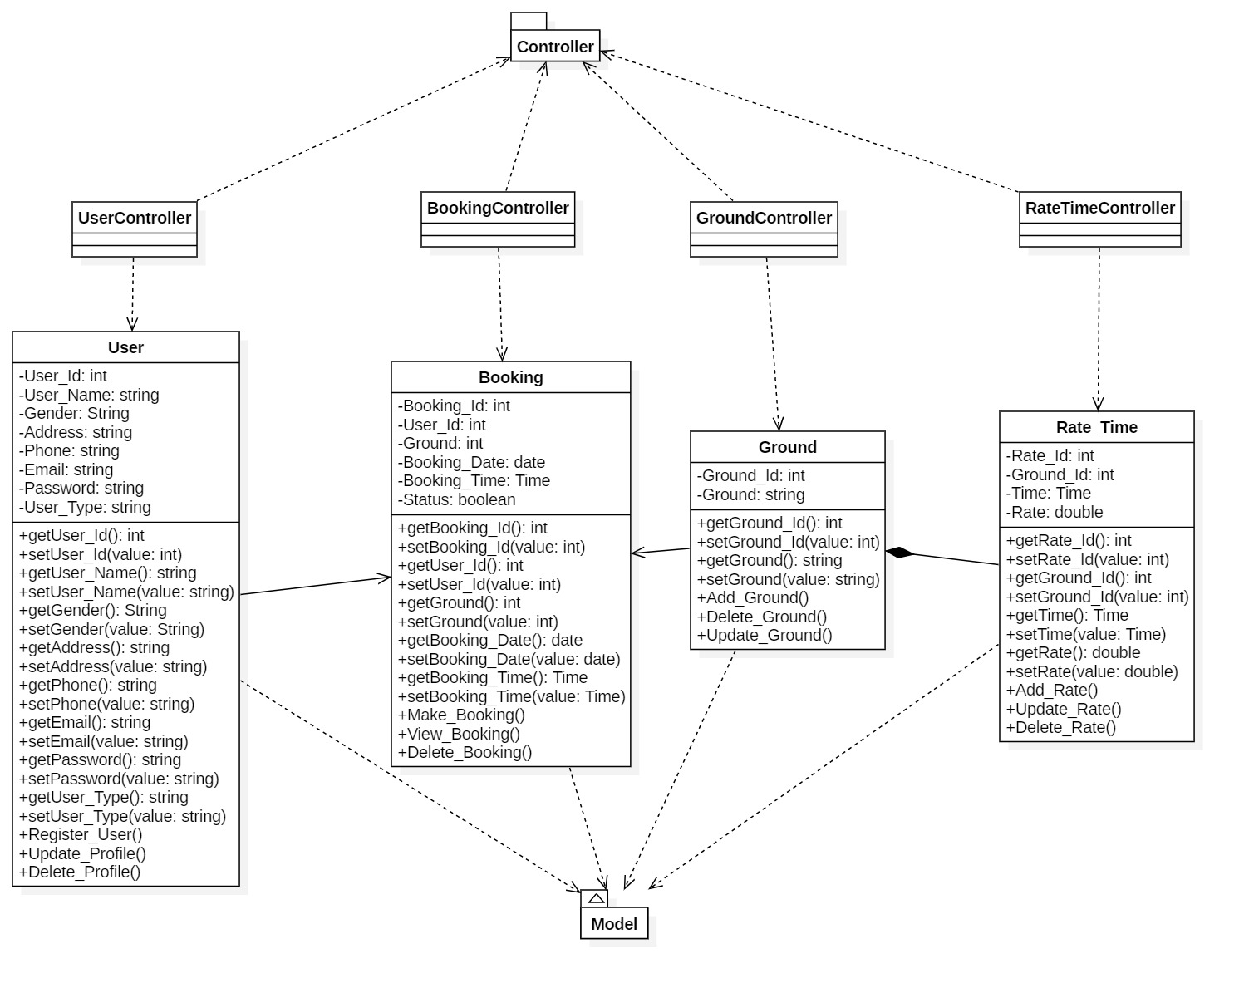

# Behavioral Model

## Activity Diagram

Activity diagrams are known as **workflow diagrams**. They are similar to flow-charts but except more structured.

In Unified Modeling Language (UML), an activity diagram is a graphical representation describing active and changing aspects of system. It connects flows from one activity to other activities in systematic and detailed way. Activity diagram is mainly focused upon flow of action sequences and respective action initiating conditions that is why is widely used for constructing methods workflow in system.

Following are the Notational Elements used in Activity Diagram:

* **Swim Lane**

Used to indicate which actors or objects are responsible for the action. They are indicated by a series of lines partitioning the diagram.

* **Initial Node**

The starting point for the diagram. This is represented by a single filled circle.

* **Activity Final Node**

The termination points for the activities. There may be several of these in a diagram. This is a filled circle surrounded by a border.

* **Flow**

The flow represents the order in which activities are performed. Indicated by arrows.

* **Fork**

A fork indicates parallel processing – activities that can be undertaken at the same time. A fork is indicated by a thick bar where one flow enters and multiple flows leave.

* **Join**

A join indicates the end of parallel processing, and is indicated by a thick bar where multiple flows enter and only one leaves.

* **Decision**

A decision represents a choice that must be taken, and is represented as a diamond with a single flow entering and one or more flows leaving.

* **Activity**

An activity is the baseline step in an activity diagram, and is represented by a rounded oval. An activity is any logically discreet action that must be taken throughout the course of the activity.

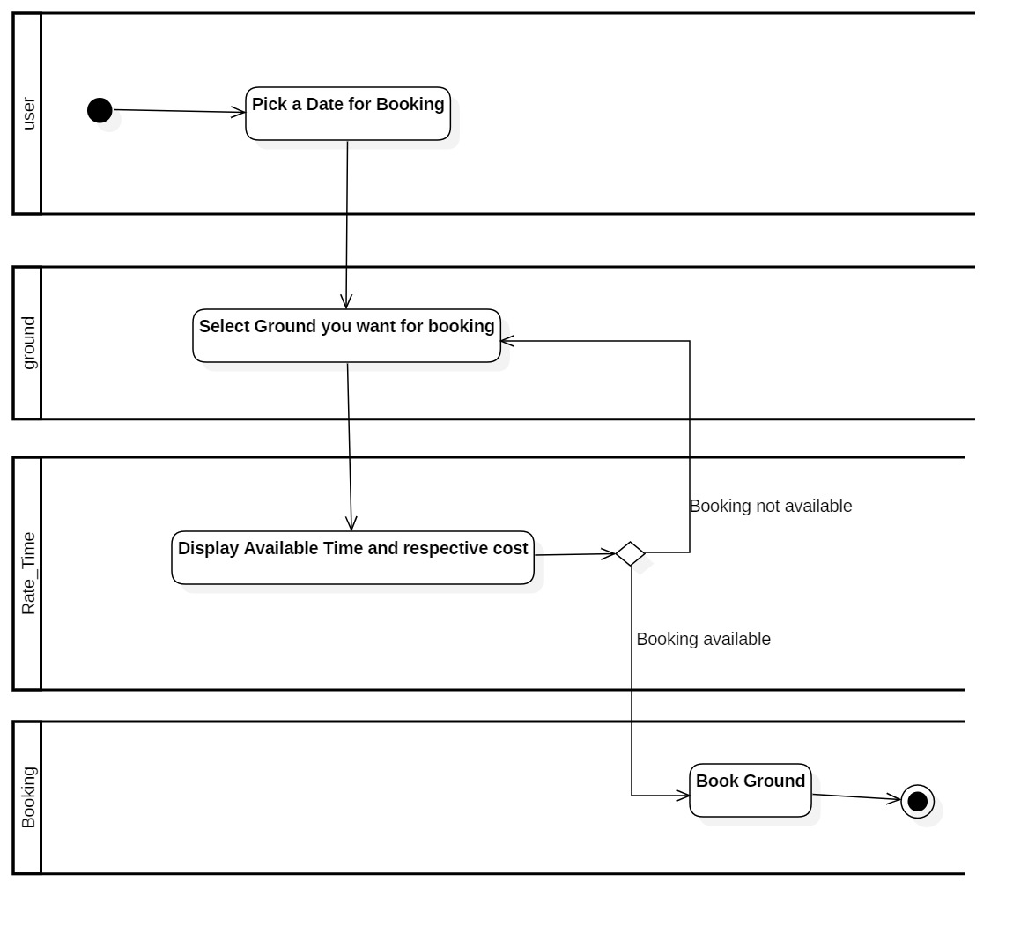

**Activity Justification**

This activity explains about process that user perform in order to make their futsal booking. Firstly, user gets log in and after that he/she pick a date for their booking and select ground that they want. After that system will display booking time slots for that ground. Now they will have a choice if they can make their booking or not. Finally, they can book a ground as their choice and end this activity.

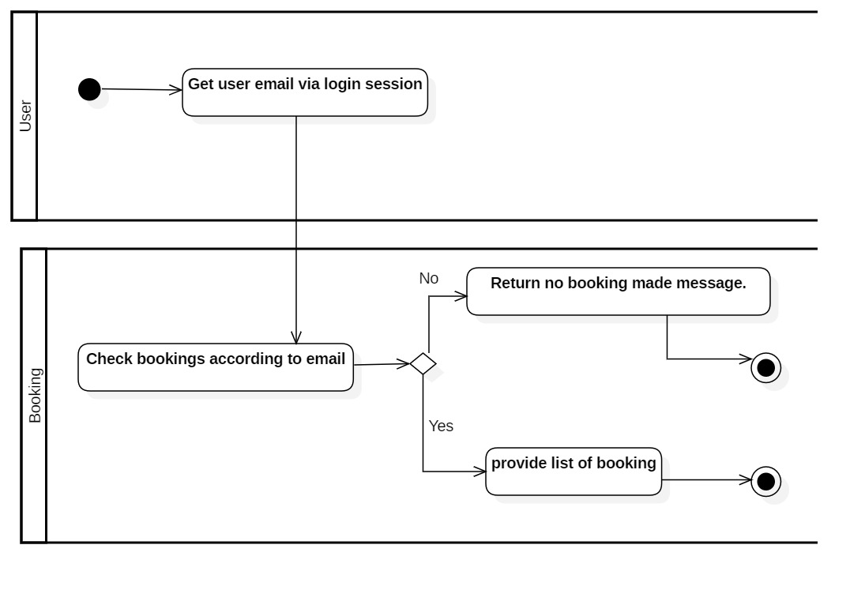

**Activity Justification**

This activity explains about process that takes in place for displaying booking that client had been made.

Firstly, after log in system will get user email via session and when user clicks on page that display their booking, system will check every list of booking made via that email id. If no result is found with that id then it will show message saying they have no booking made and if it found results in booking list then it will display every booking made by them in respective web page.

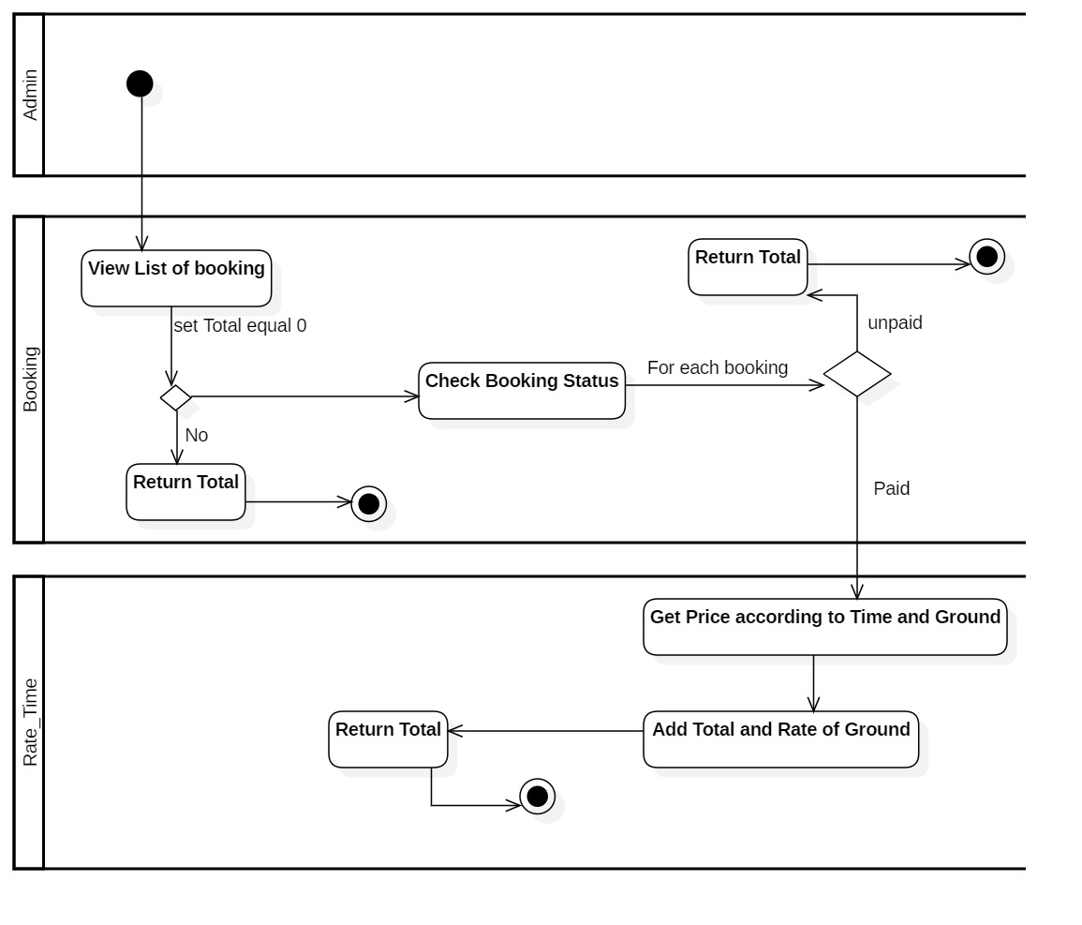

**Activity Justification**

This activity shows that how admin can calculate total amount that they earned via booking. Here admin will list all bookings and after listing all booking. If booking were made then system will return 0 as total value and if booking exists then it will sum all prices of that booking whose status are paid if not paid then system will return 0 as total. Finally, total sum is returned as their earning.

## Sequence Diagram

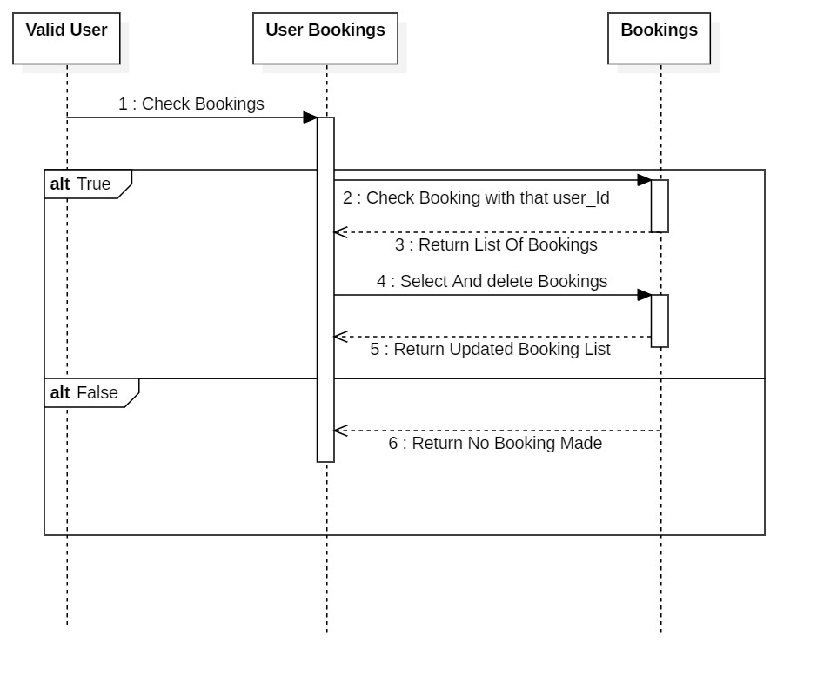

**Justification**

Firstly, when user gets authenticate and access to their respective dashboard, he can access to their booking list that they made. Here, user goes to bookings and system checks if booking available or not automatically. If they had got their booking list then he will be provided with booking delete option where he can delete his booking. When he deletes their booking system will remove booking from booking table and provide respective booking list respectively.

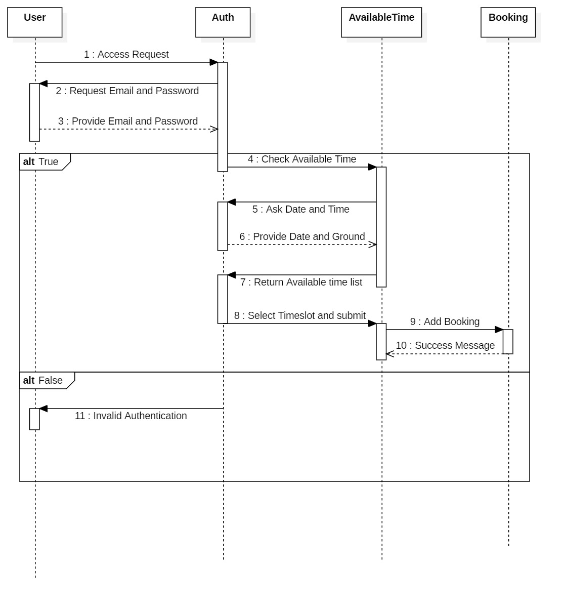

**Justification**

Here, user request for access to booking page where system ask to provide Valid Email and Password. Then, user provide valid user email and password. Now, system processed for authentication for provided user email and password. If it gets authenticate successfully then they request for available time. Again, system ask them for Date and Ground for booking and then user provide date and ground as their interest. Now, system will Provide available list of timeslots. Finally, user select timeslot as their interest and submit booking and system will add that booking to database and return success message.

However, if user doesn’t get authenticated then system return invalid authenticate message and ask them to provide valid Email and password.

# Database Design

The Entity Relationship Diagram is simply a graphical way of representing data and their relationship with other data. Normally defines how entities like objects, peoples, concepts are related to each other. Three types of methods are present in order represent data using ER diagram, they are UML, Crows Feet and CHEN. I produced EG Diagram using Crows Feet method using software known as Oracle Visual Paradigm.

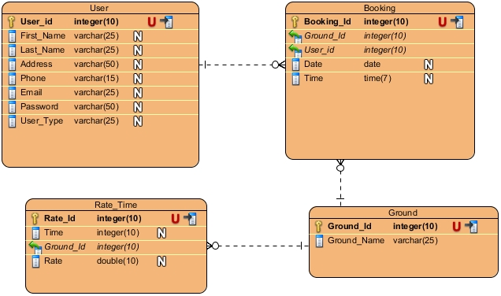

## UI Modelling Prototype

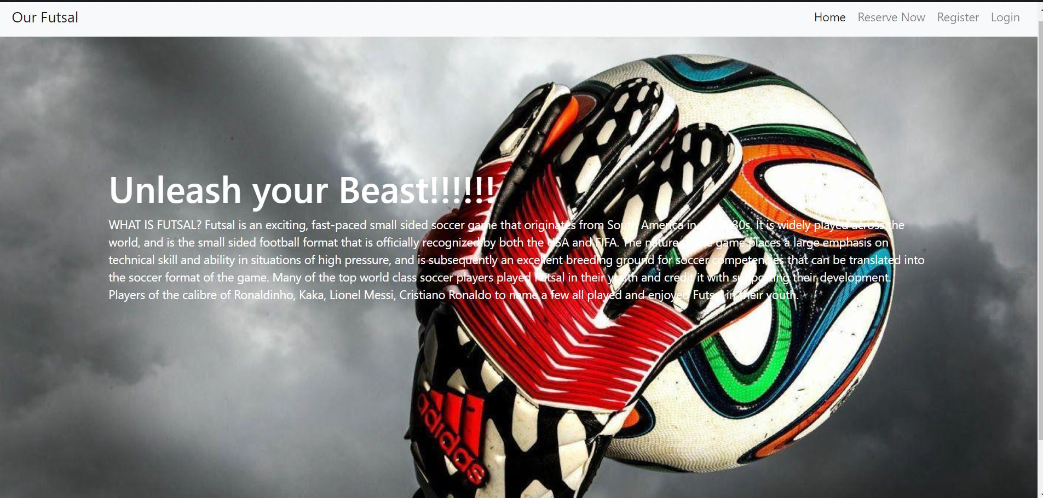

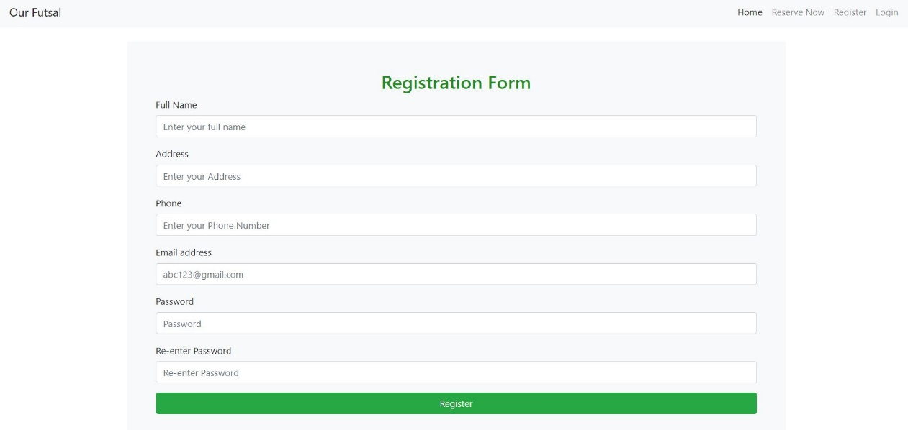

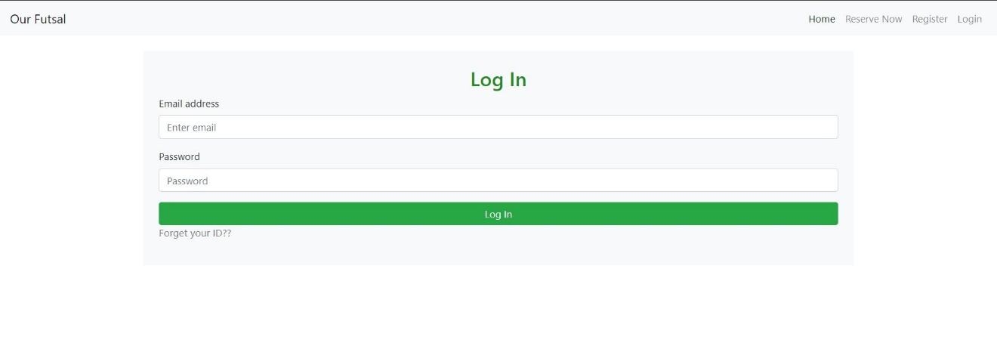

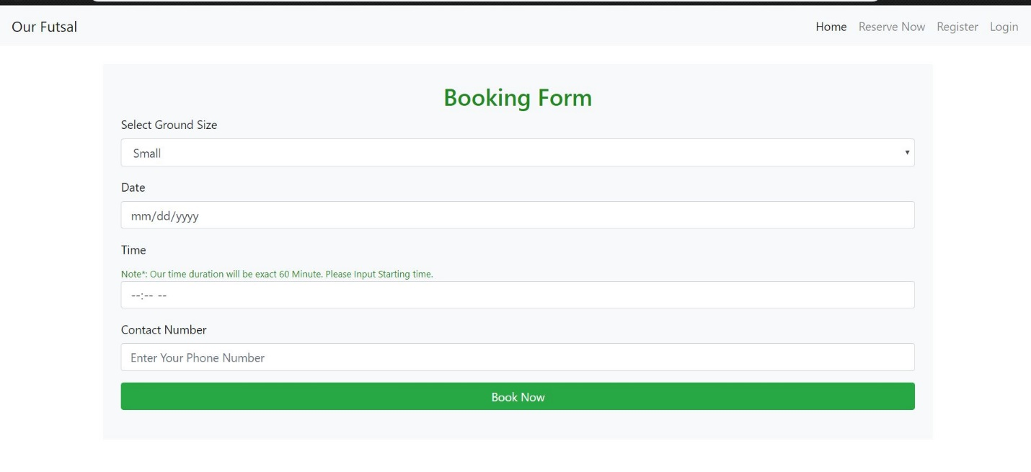

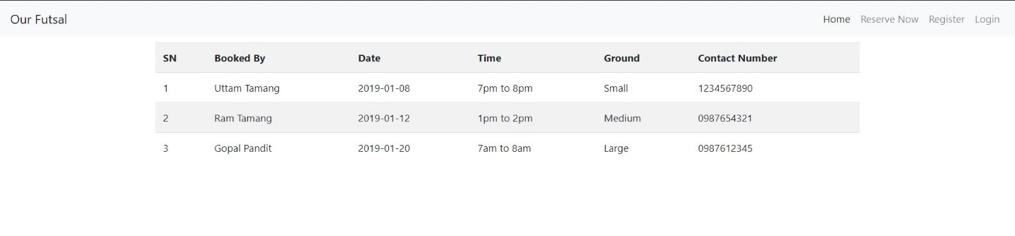

# **Chapter 4**

# Implementation

# Language (PHP)

PHP is a server-side scripting language. that is used to develop Static websites or Dynamic websites or Web applications. PHP stands for Hypertext Pre-processor, that earlier stood for Personal Home Pages.

PHP scripts can only be interpreted on a server that has PHP installed.

The client computers accessing the PHP scripts require a web browser only.

A PHP file contains PHP tags and ends with the extension ".php".

# Framework (Laravel)

Laravel is a powerful MVC PHP framework, designed for developers who need a simple and elegant toolkit to create full-featured web applications. Laravel was created by Taylor Otwell.

Laravel is a web application framework with expressive, elegant syntax. Laravel attempts to take the pain out of development by easing common tasks used in the majority of web projects, such as authentication, routing, sessions, and caching. Laravel aims to make the development process a pleasing one for the developer without sacrificing application functionality.

Laravel is accessible, yet powerful, providing powerful tools needed for large, robust applications. A superb inversion of control container, expressive migration system, and tightly integrated unit testing support give you the tools you need to build any application with which you are tasked.

# Development Methodology

Waterfall methodology is use for development of this project. Waterfall model is commonly used software development methodology guaranteeing the success of the working software. It’s consisting of different phases which ensures your success development process of the project.

Advantage of waterfall model includes:

* Easy to understand and use
* Fixed and clear phases and rules that you have to follow when you move from one phase to another.
* Easy maintenance
* You can review your progression over time
* Well documentation

**Diagrammatic representation of waterfall model is given below:**

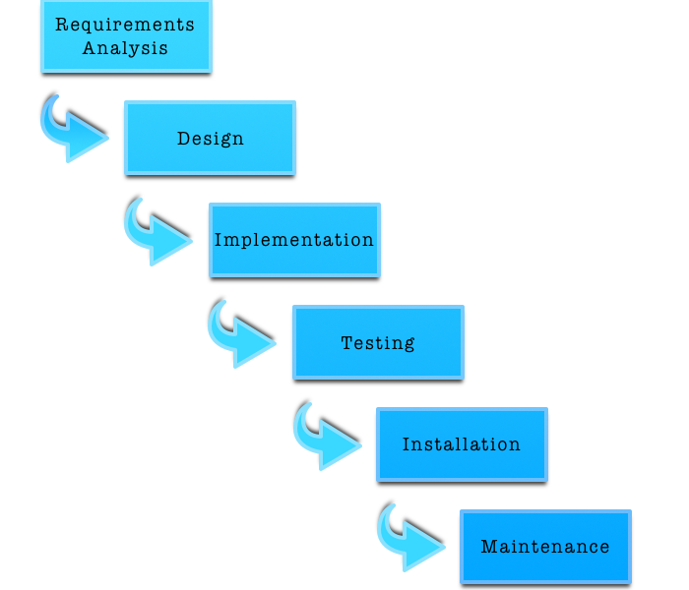

**Different phases of waterfall model and their goals:**

**Requirement analysis**

* System requirements that need to be established are completely captured and documented.

**System Design**

* With help of first phase of waterfall model system design is prepared in this phase and then overall system architecture is prepared.

**Implementation**

* In this phase, system is developed in small programs which are called units.
* This phase is also known as **Development and Coding**.

**Testing**

* Now, those units get integrated in this phase and perform testing in order to prevent from defects/faults and failure.

**Deployment/Installation of system**

* After testing now software is installed or get released.

**Maintenance**

* After installation of software, identified issues and defects gets resolved with release of patches as well as newer versions of that software.

# Design Pattern

Generally, design patterns are those solution which helps in commonly occurring problem in software design. Usually, they act as template explaining how to solve those problems.

**MVC (Model View Controller) design pattern** is the one which I have choose as it is commonly used architectural pattern for UI design.

It divides system into three different parts yet interconnected with each other and allocate specific responsibilities.

Different parts and their responsibilities:

**Model**

* Central part and independent to UI
* It manages data, logic, rules of the application
* It receives data od an application with help of controller

**View**

* Basically, view handles UI design of an application

**Controller**

* It accepts user inputs and translate it as command for Model or View.

Advantage of MVC design pattern are as follows:

* It allows simultaneous development of divided parts i.e. Model, View and Controller
* Low coupling in system architecture
* High cohesion in code structure
* It facilitates multiple view for model.

# UI Design

Home

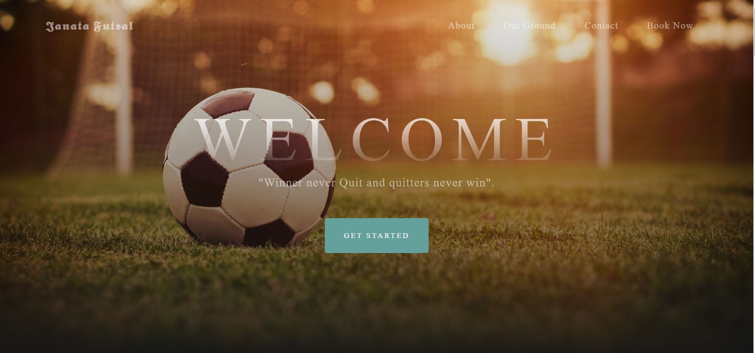

Login

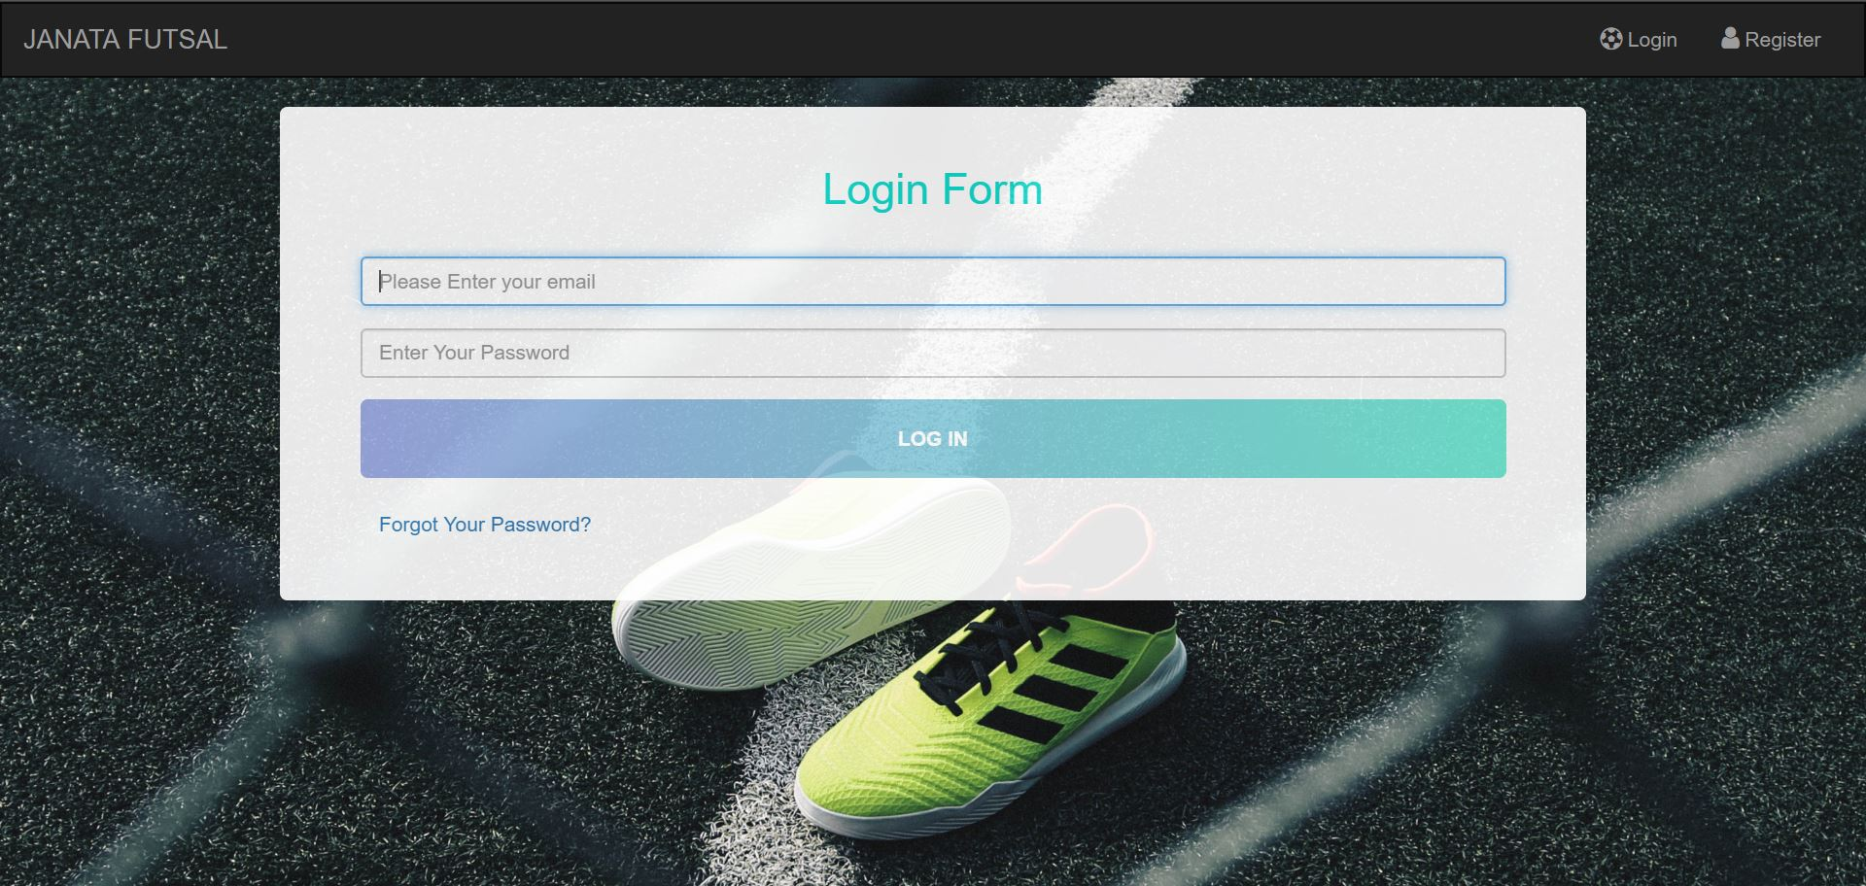

Registration

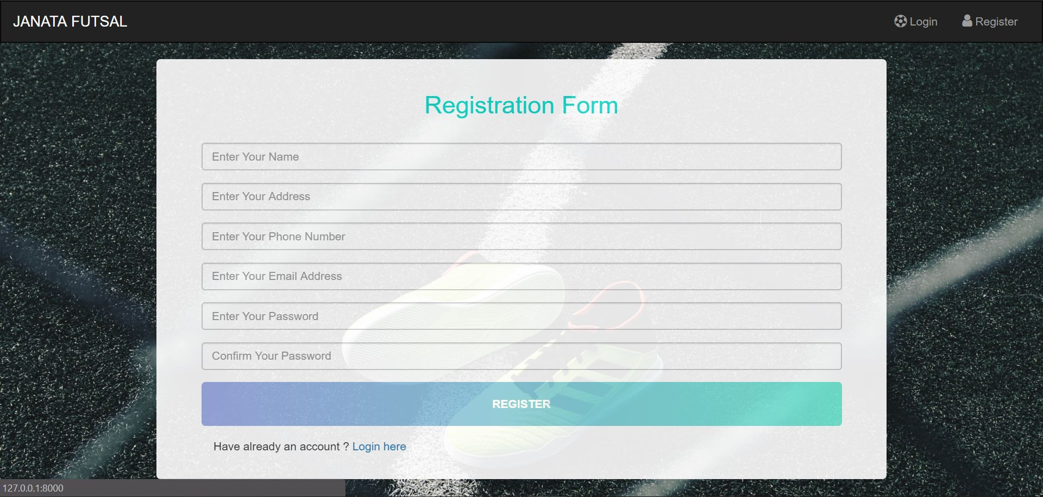

Admin Dashboard

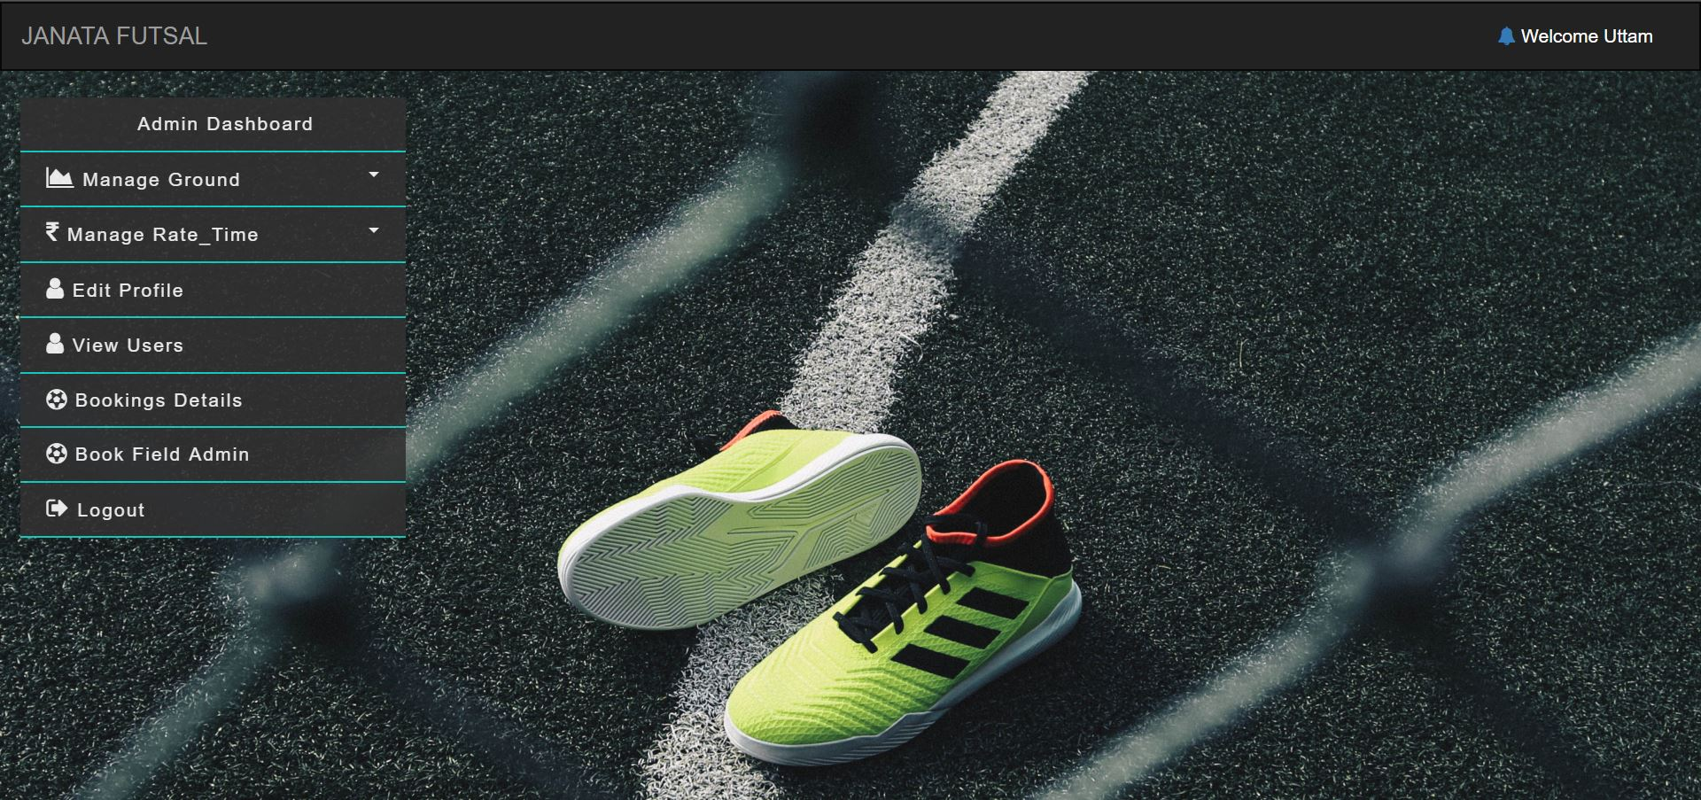

Client/Customer Dashboard

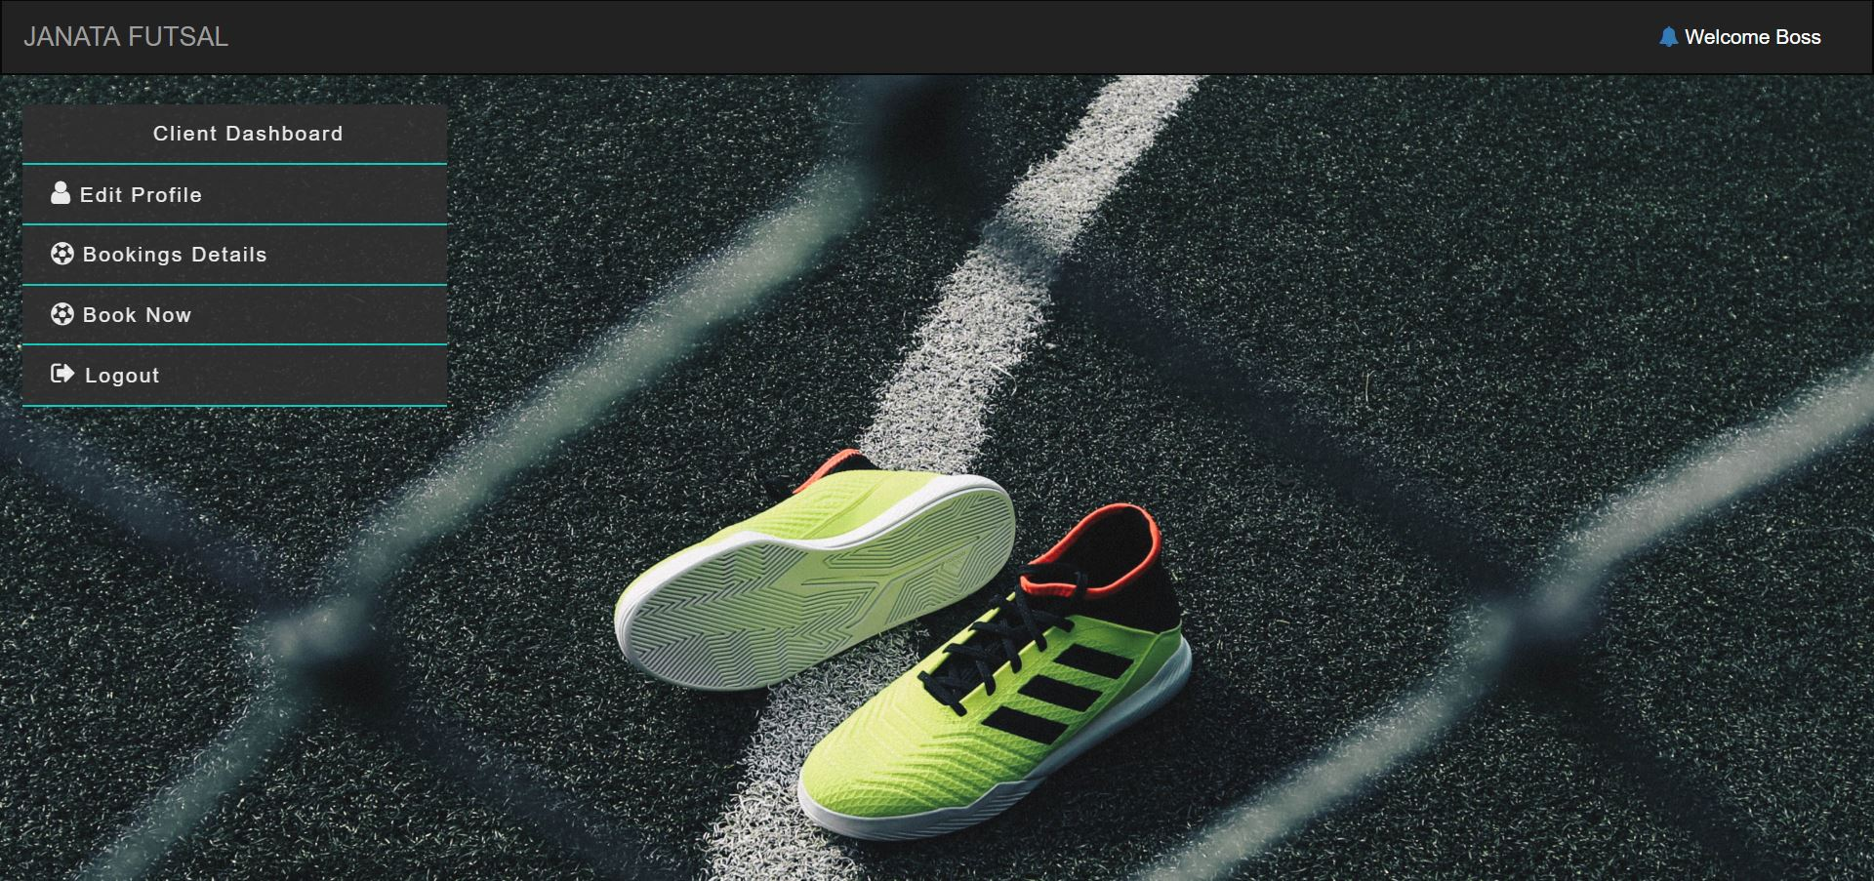

# **Chapter 5**

# Testing

## Unit Testing

**Test Cases**

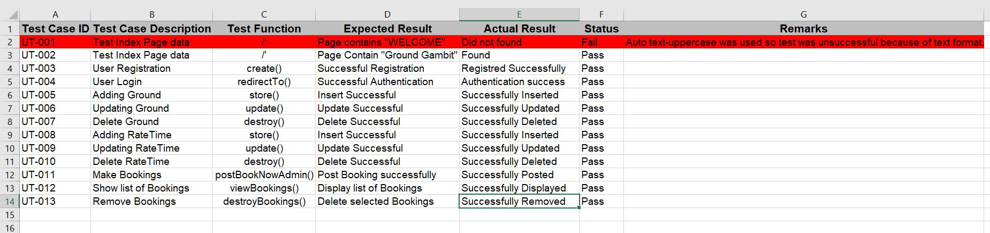

**Test Performed result (14 passed and 1 failed)**

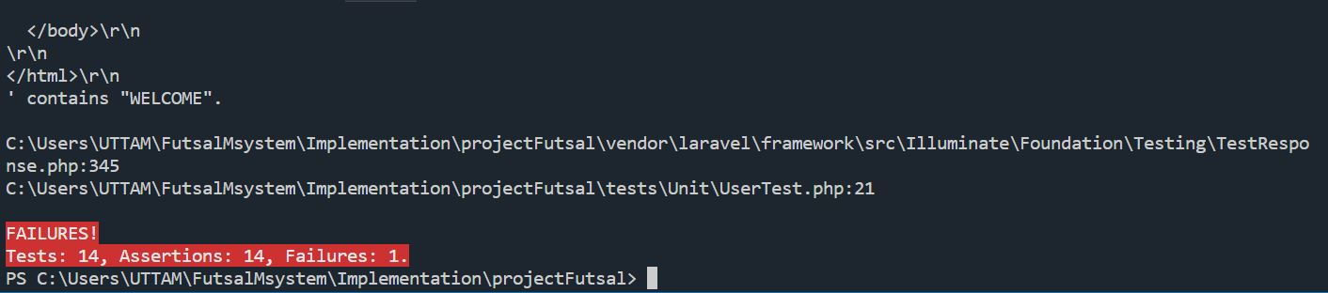

**Note: Every Screen shot of Unit Testing are present at Appendix Chapter.**

## Black Box Testing

Test 1: Login for Admin

Result: Pass

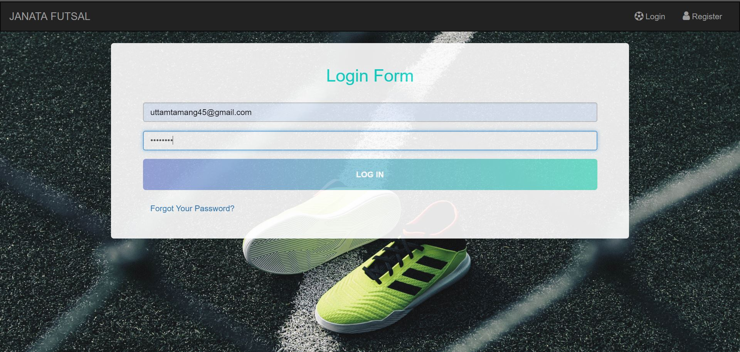

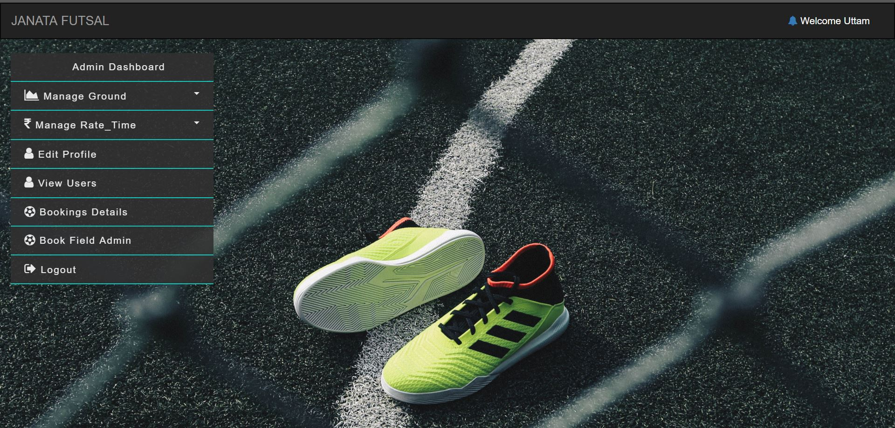

Test 2: Login for Client/Customer

Result: Pass

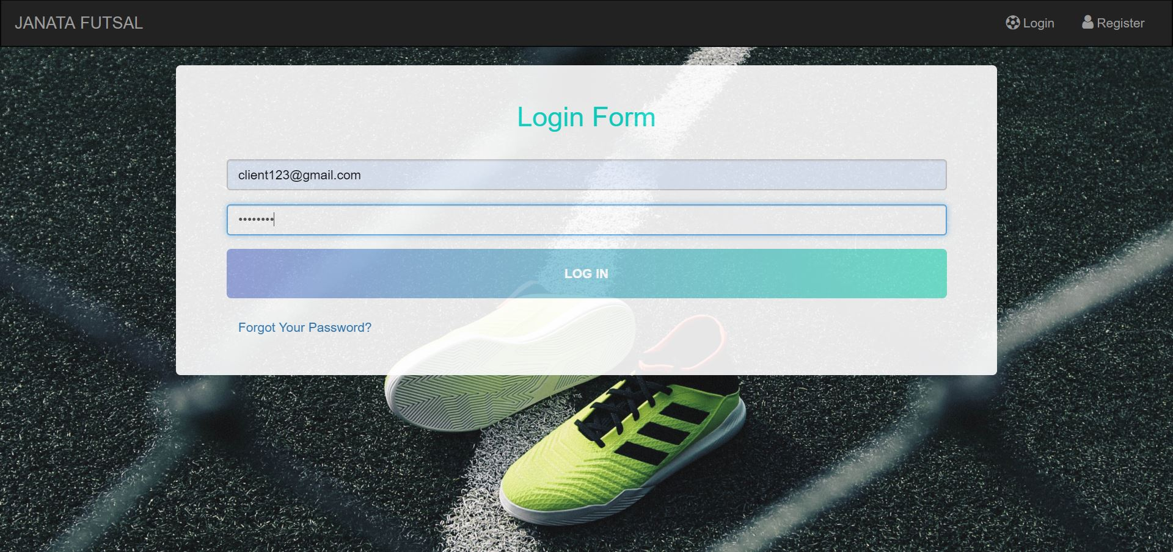

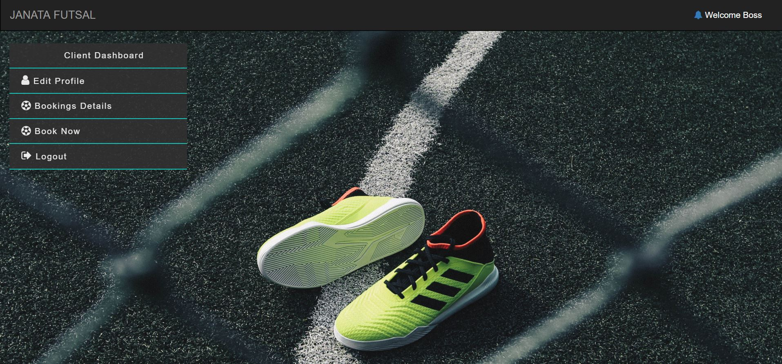

Test 3: Edit Profile

Result: Pass (Name changed from boss to Update)

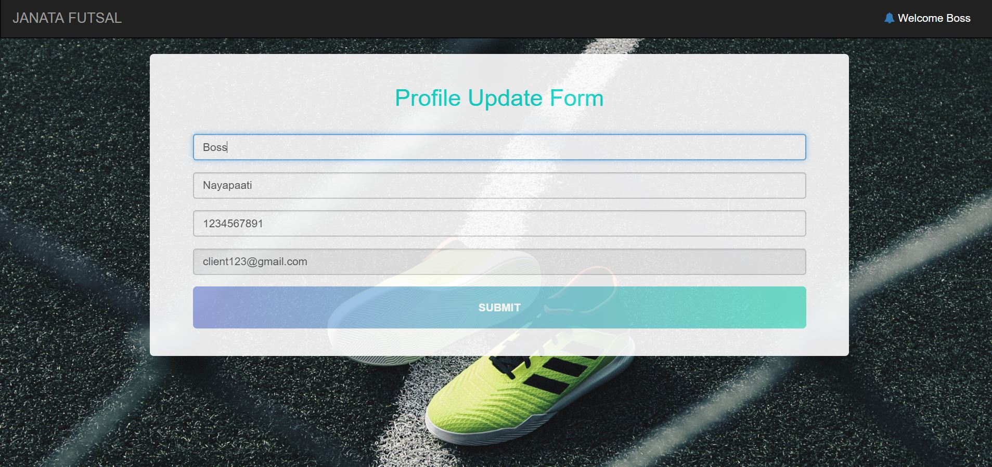

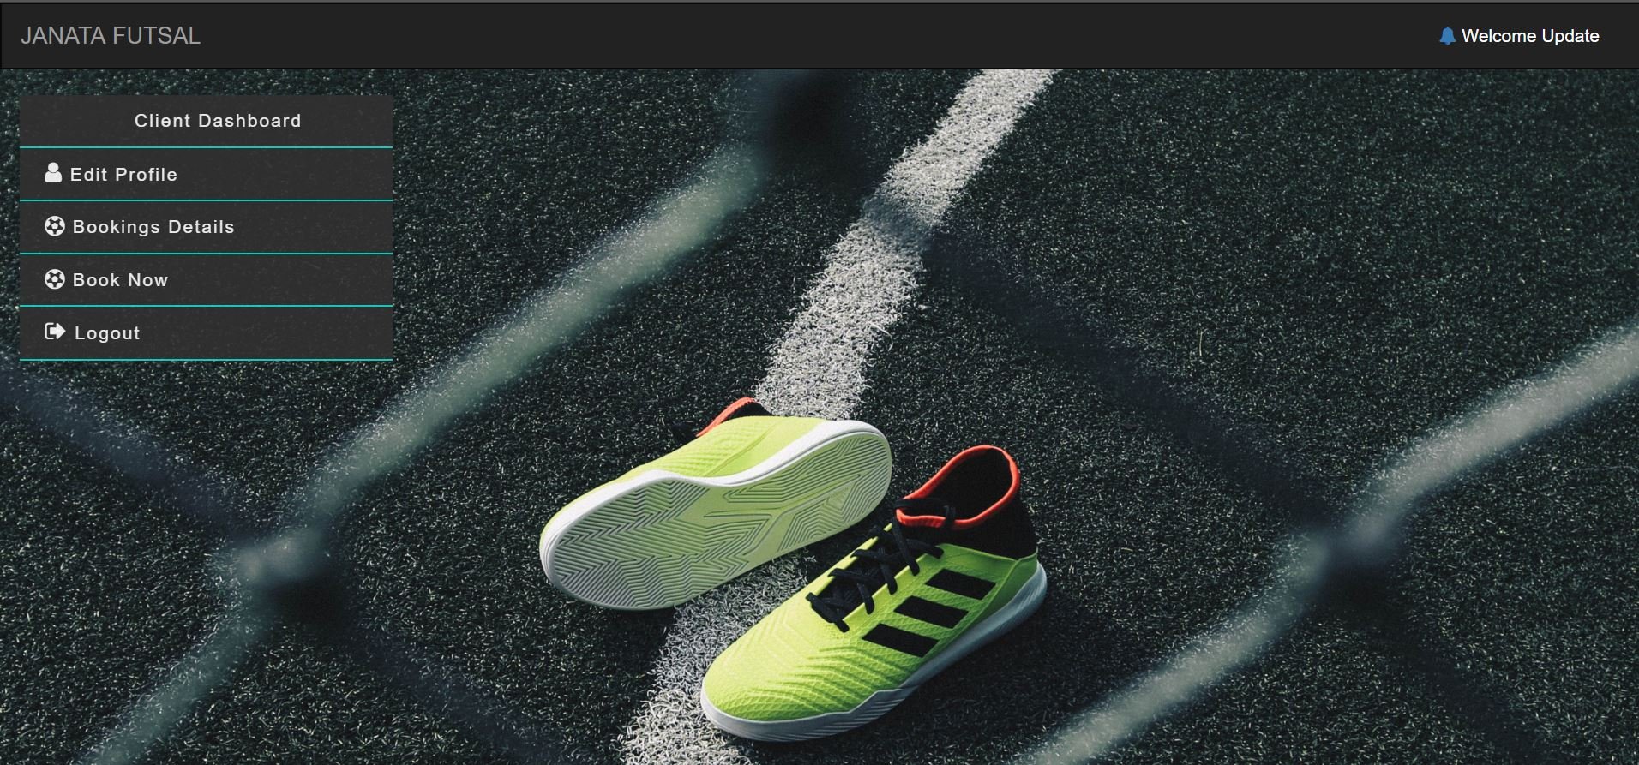

Test 4: Adding ground by admin

Result: Pass

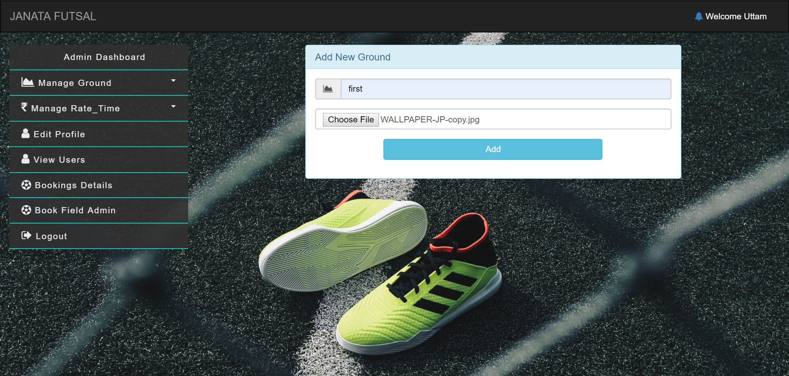

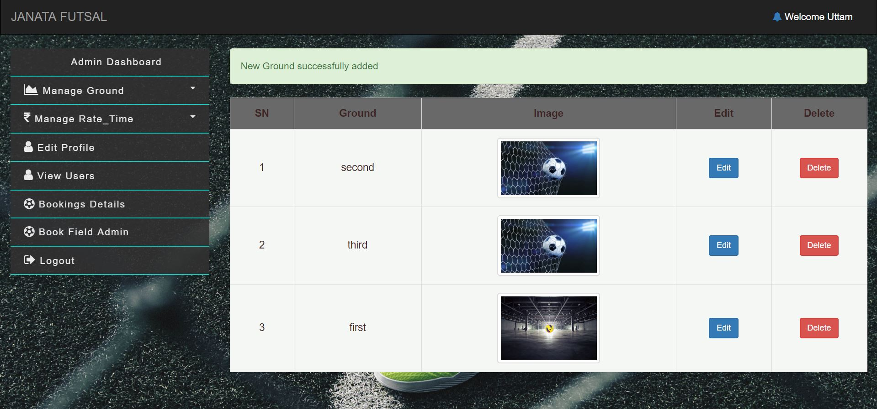

Test 4: Updating Ground

Result: Pass

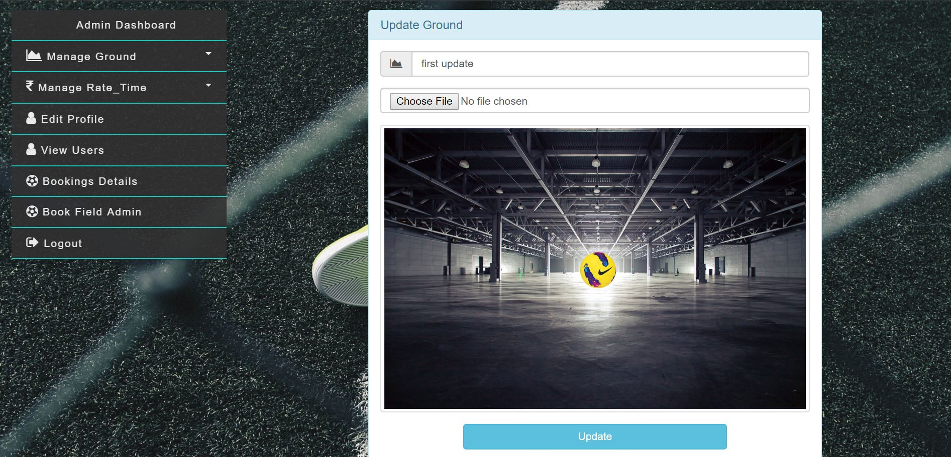

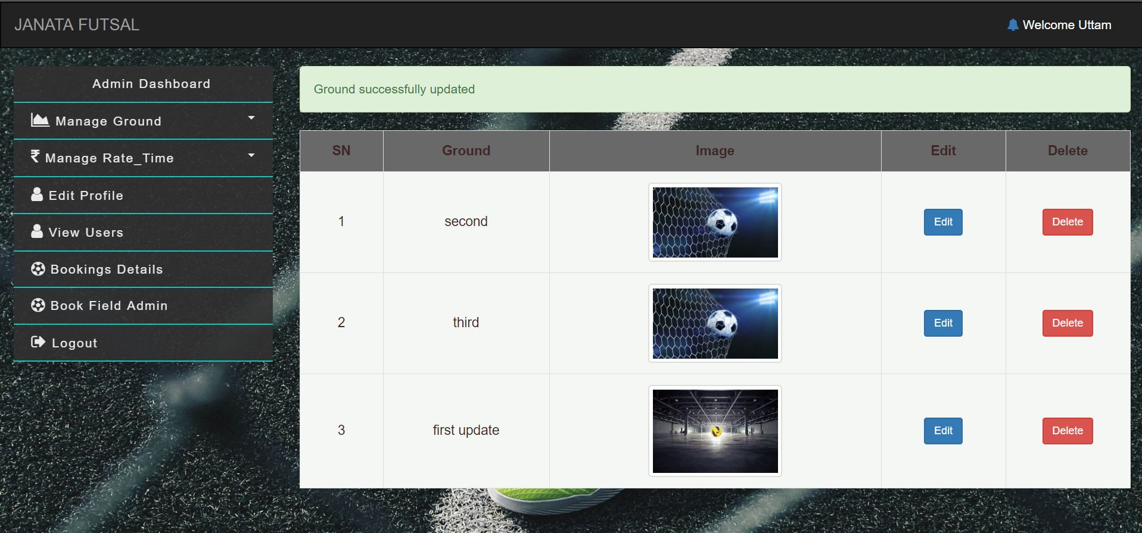

Test 5: View User for Admin (All as well as Specific)

Result: Pass

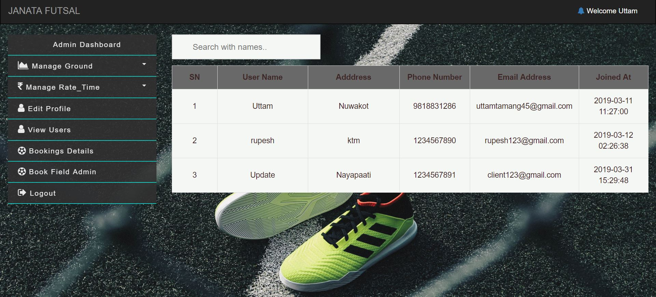

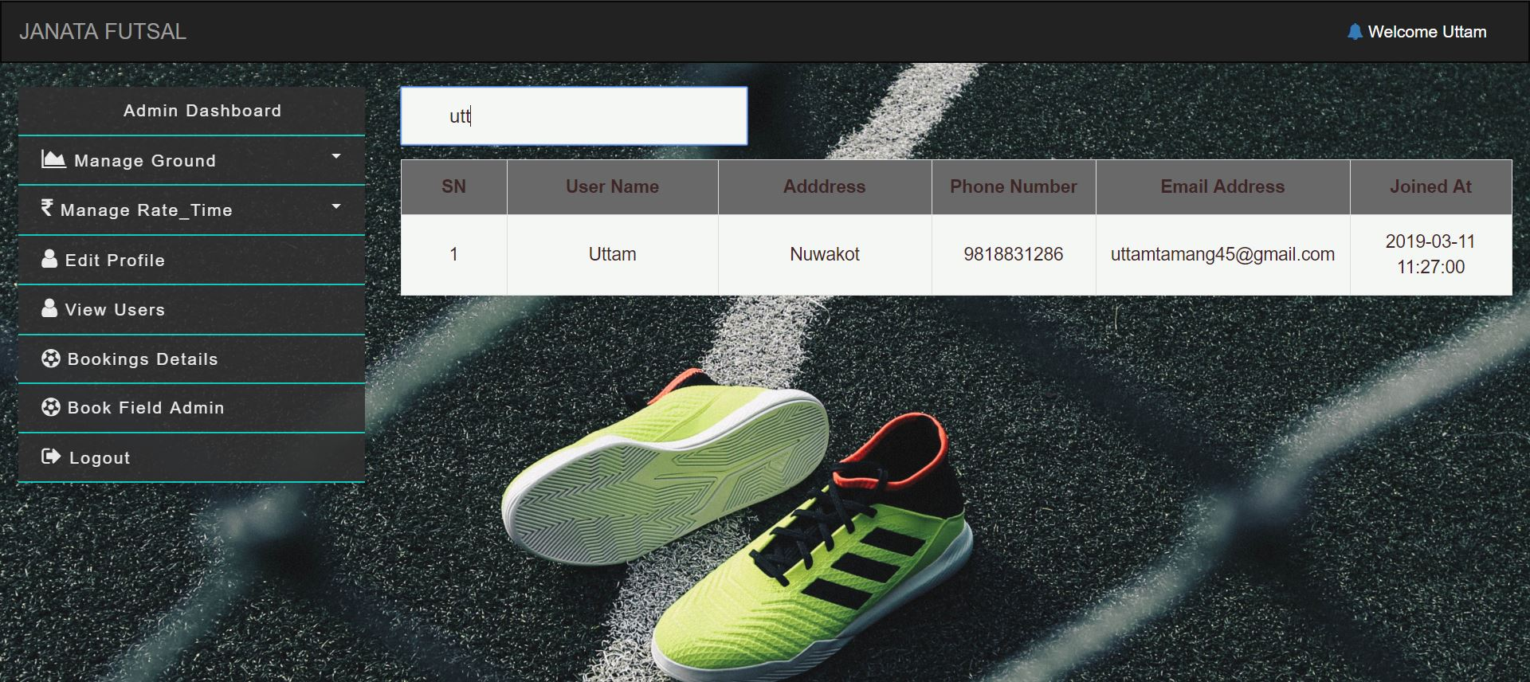

Test 6: View Booking list with Total collection

Result: Pass

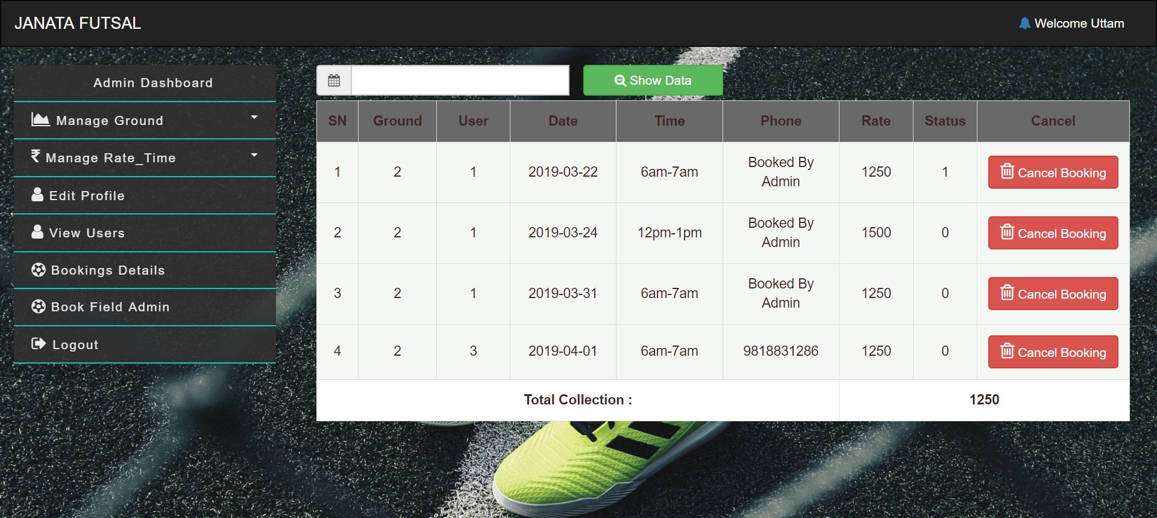

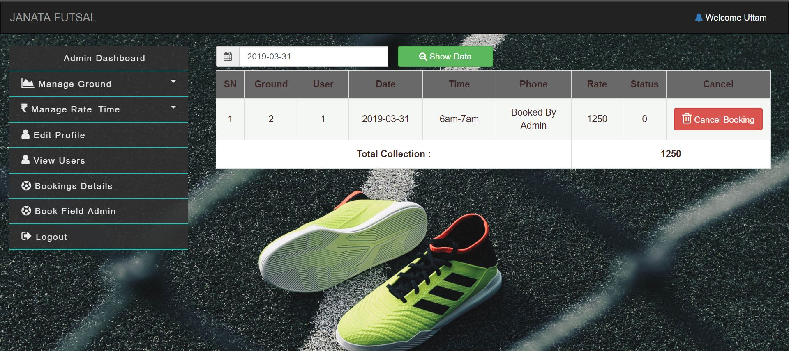

Test 7: Checking Available Time

Result: Pass

Note: Red button shows Booked time and Blue Button represent Available time.

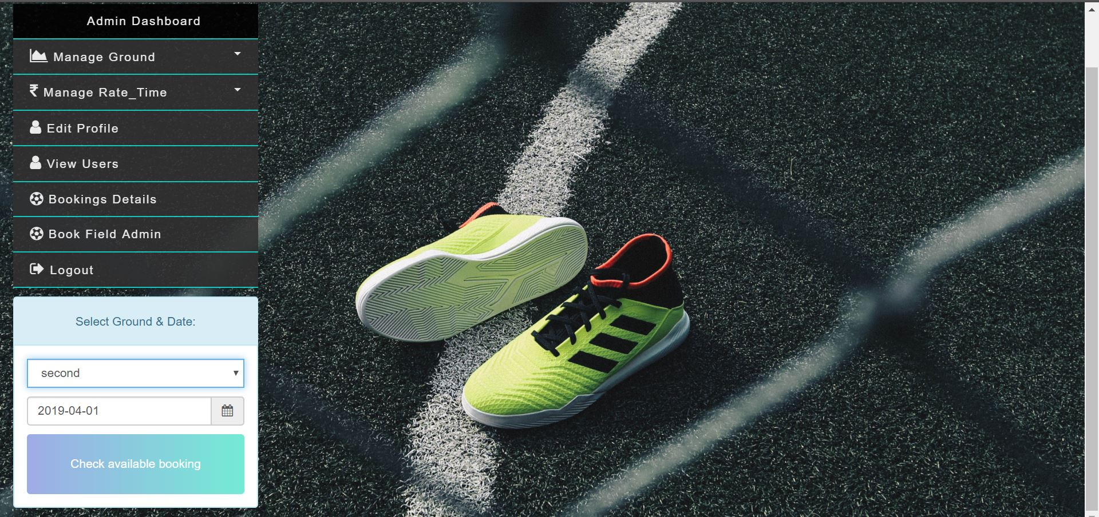

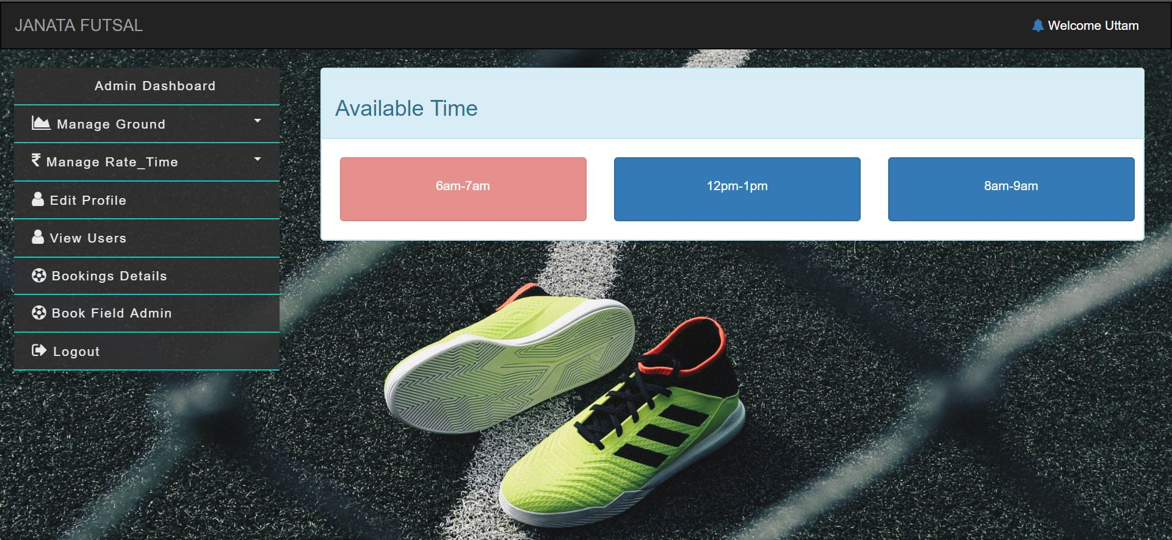

Test 8: Client Booking

Result: Pass

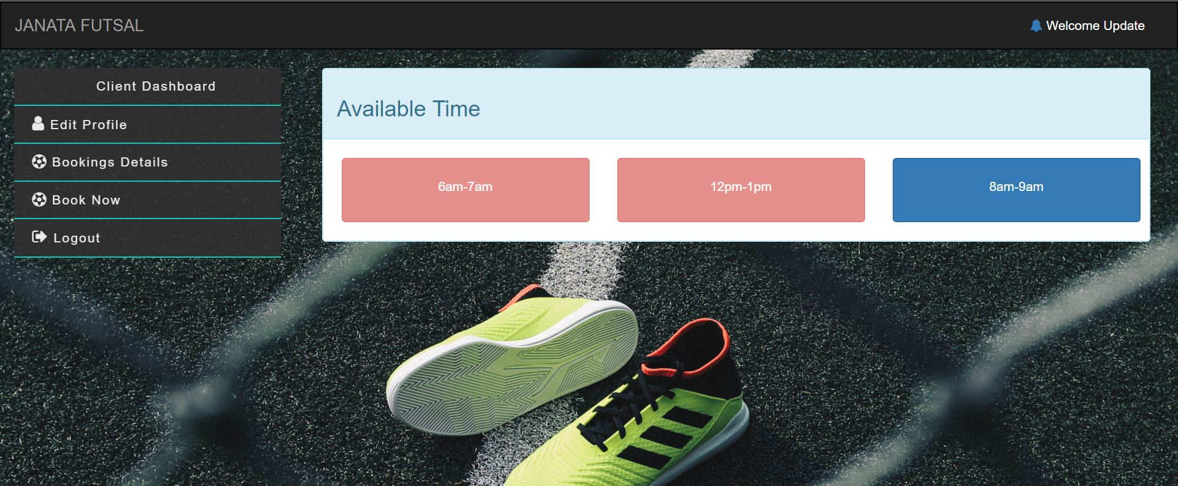

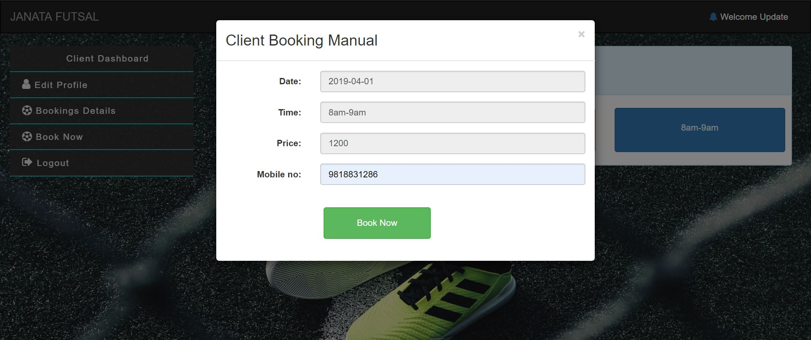

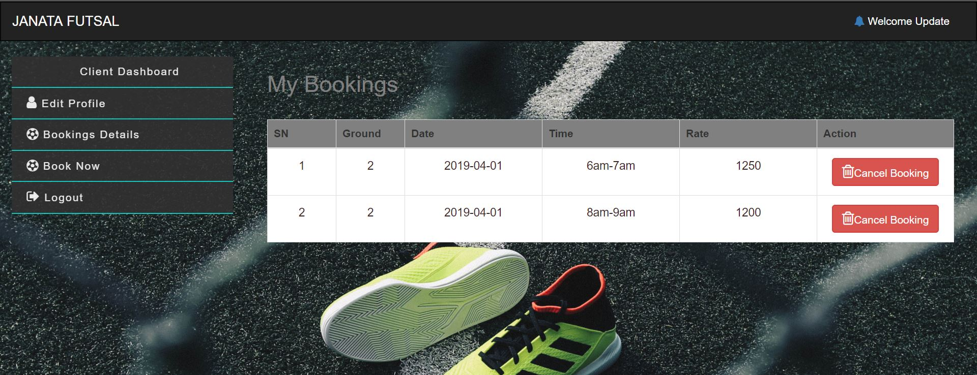

Test 9: Client Booking Cancel

Result: Pass

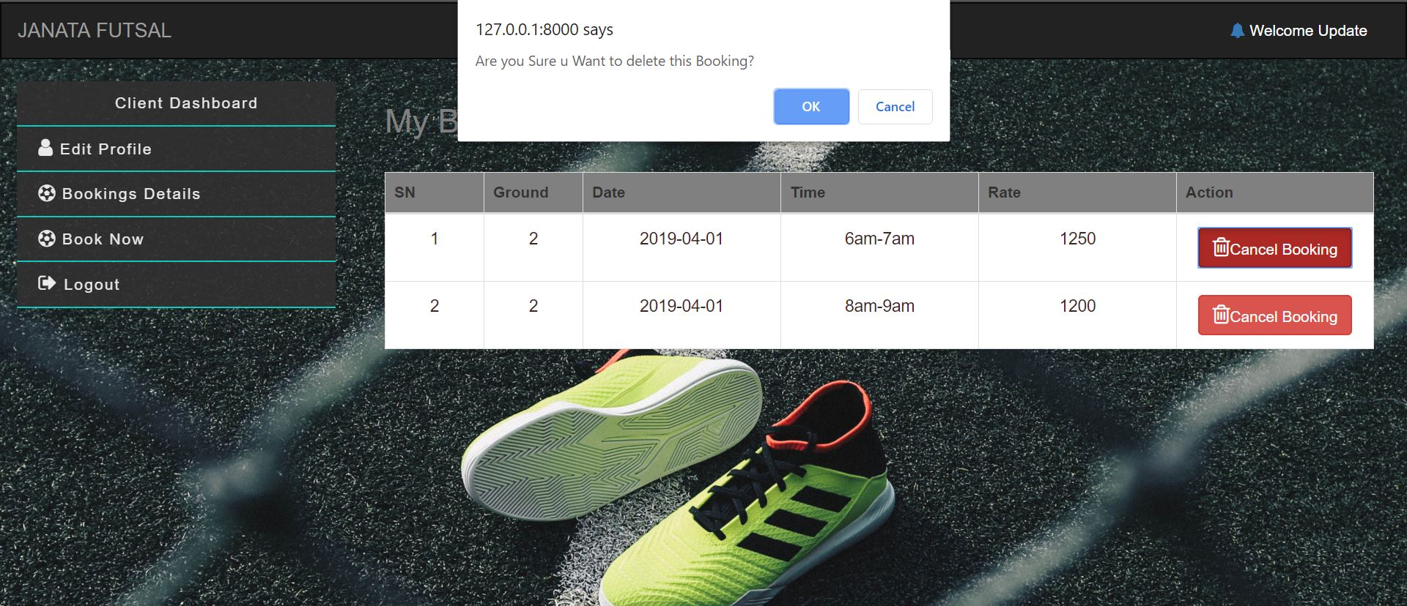

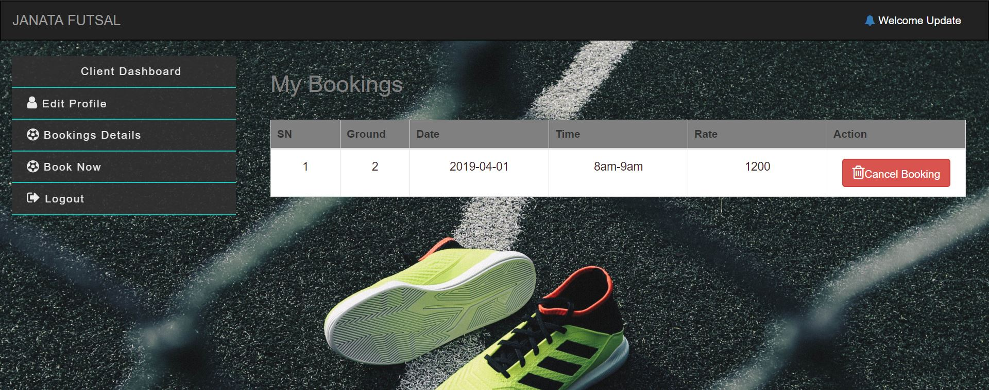

# **Chapter 6**

# Other Project Issues

## Risk Management

|  |  |  |  |  |  |
| --- | --- | --- | --- | --- | --- |
| **SN** | **Risk** | **Likelihood** | **Consequences** | **Impact** | **Solution** |
| 1. | Insufficient resources | 2 | 3 | 6 | Keep each and every resource that you are going to use in a sufficient amount. |
| 2. | Server failure | 1 | 5 | 5 | Facility of a backup system can be done. Either cloud based or physical. |
| 3. | Delay in Development | 2 | 5 | 10 | Strict scheduling and planning with collaboration among team will lead to quicker development. |
| 4. | Badly Designed UI | 1 | 4 | 4 | With preforming good requirement gathering as well as collaborative UI designing between user and Developer be solution for this. |
| 5. | Uncertain Growth of requirements | 1 | 4 | 4 | Having certain level of contract between client and developer and good requirement analysis solve this issue. |
| 6. | Overly Featured | 2 | 2 | 4 | By preventing developer from show off their skill by adding unnecessary features. |
| 7. | Financial Issues | 1 | 4 | 4 | Always schedule and planning budget accordingly will help with this situation. |
| 8. | Outdated Developer’s Skill | 1 | 5 | 5 | Employee training and encouraging for learning new skill will solve this problem. |

## Work Breakdown Structure

Work breakdown structure is simply a process of breaking down your project into smaller manageable parts, so that you can understand and manage easily as well as more effectively. Generally, WBS is represented as Tree like structure with different task and their interrelated sub tasks.

Diagrammatic representation of WBS scheduling is:

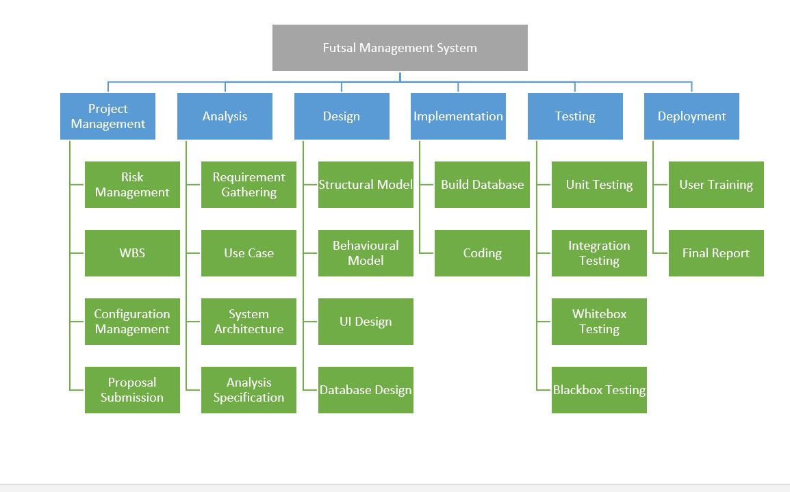

## Configuration Management

Configuration management of a project refers to collection of processes, activities, tools and methods which is performed by professionals to manage items and resources during the project life cycle. Usually, administrators or professionals uses configuration management to authenticate a change made during to one configuration item has on other systems. These items could be both hardware or software even documentations.

In my project I have used git for backup my project progression and documented associated with it.

Also, git provide **version control** mechanism which will be provide extra edge in development, maintenance and backup system. Version control simply means a system that records changes in a file or collection of files over time so that you can recall specific version later.

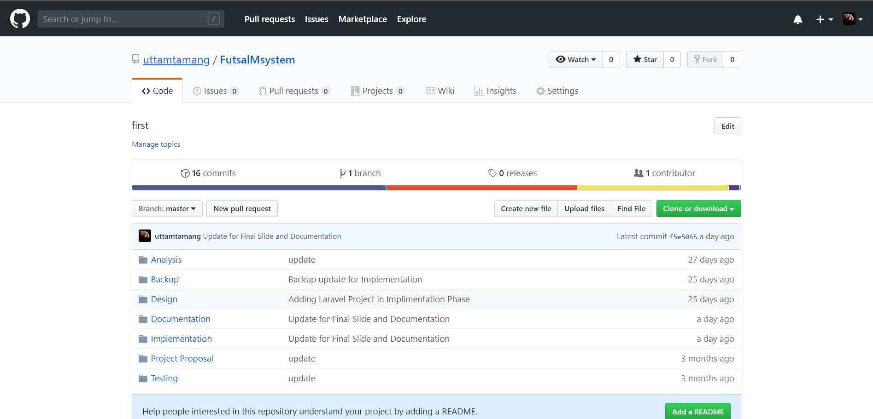

# **Chapter 7**

# Conclusion

Finally, desired Web Application for futsal booking management is created successfully. Which will now automate online registration, booking and management functionality for both clients and Admins. As per requirement application meets most of functionality ( All from Must Have Functionality and some from Should Have and Could Have ) we listed on MoSCoW list.

However, many of necessary functionality lacks in solution. Which will fixed from future update.

# **Chapter 8**

# References

Anon., 2018. *izenda.com.* [Online]   
Available at: https://www.izenda.com/blog/5-benefits-3-tier-architecture/  
[Accessed 03 01 2019].

Anon., 2018. *simplicable.com.* [Online]   
Available at: https://simplicable.com/new/system-architecture-definition  
[Accessed 03 01 2019].

# **Chapter 9**

# Appendix

## Unit Testing

Test: UT-001

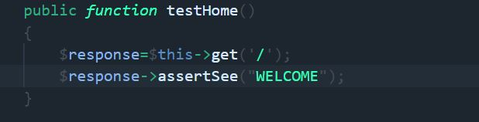

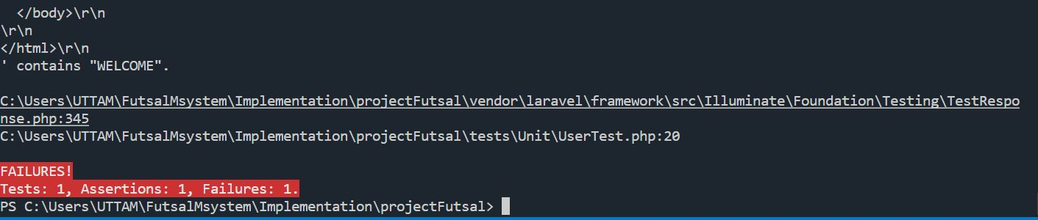

Test: UT-002

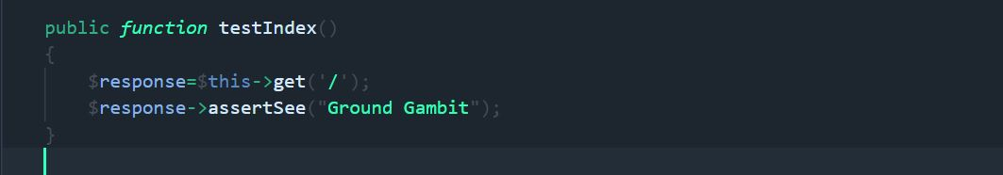

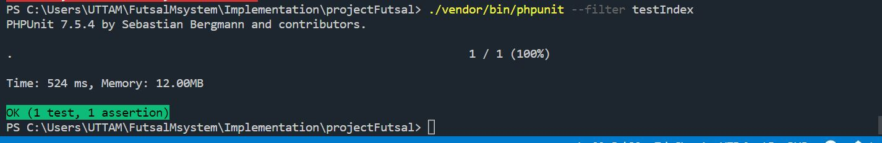

Test: UT-003

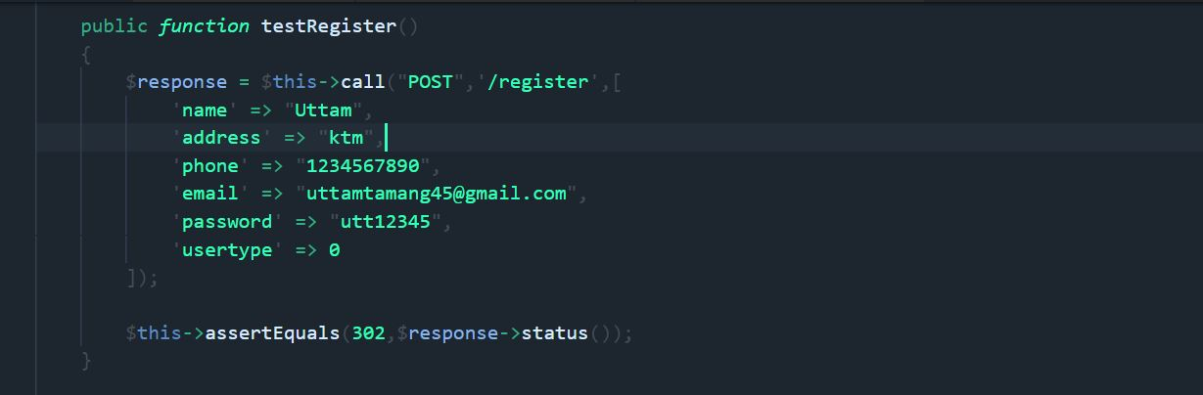

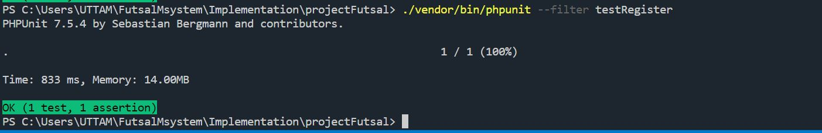

Test: UT-004

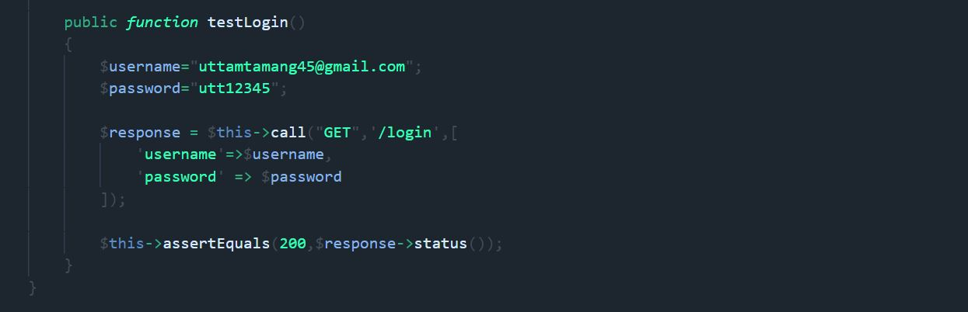

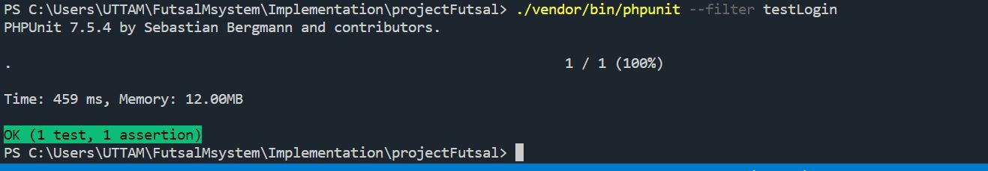

Test: UT-005

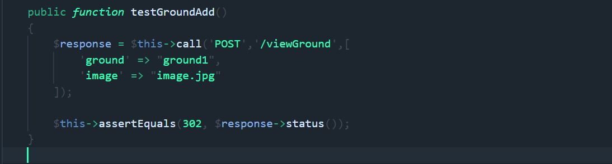

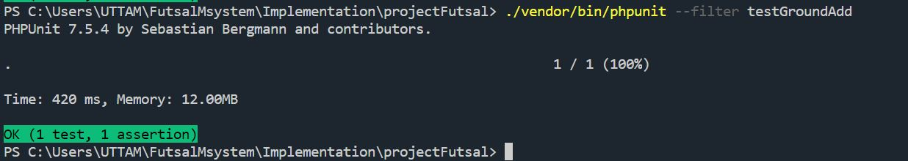

Test: UT-006

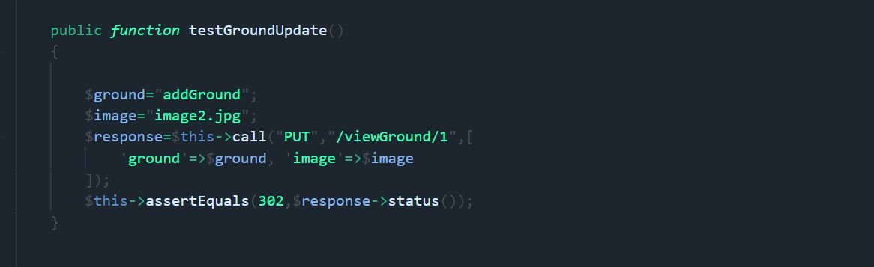

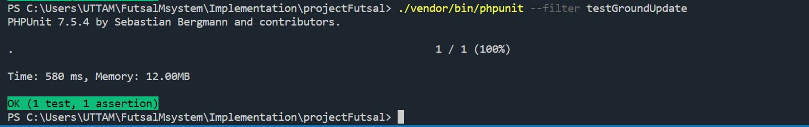

Test: UT-007

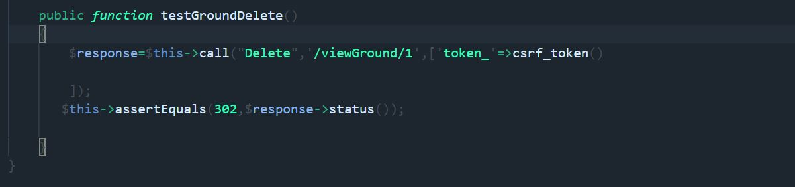

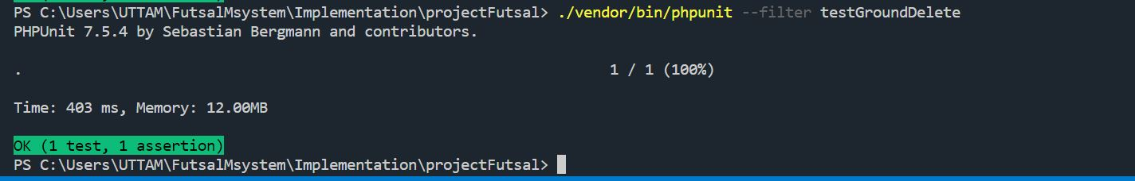

Test: UT-008

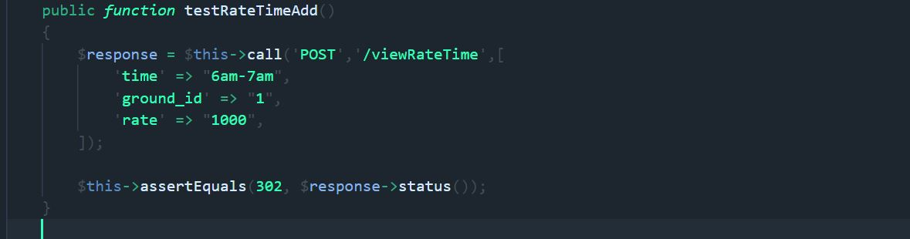

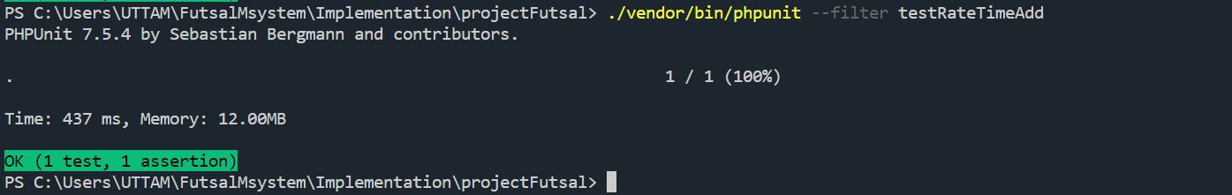

Test: UT-009

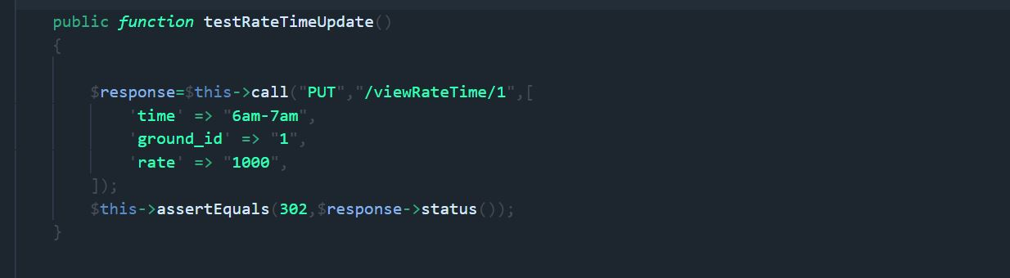

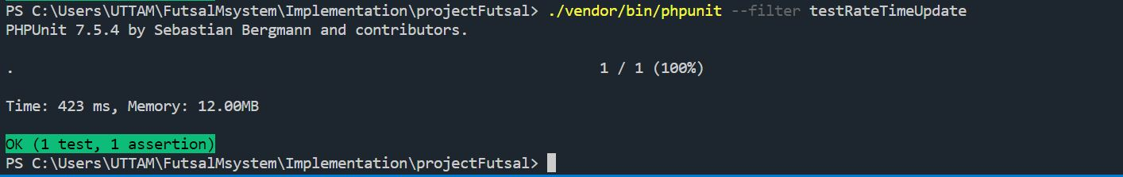

Test: UT-010

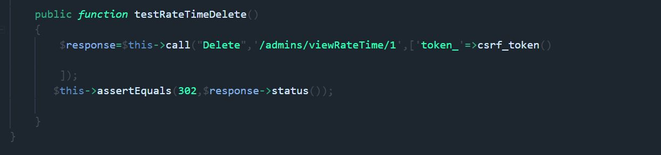

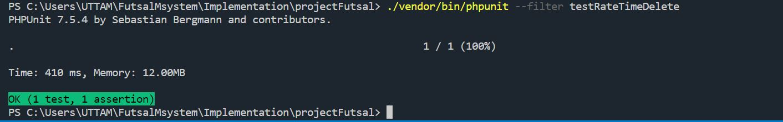

Test: UT-011

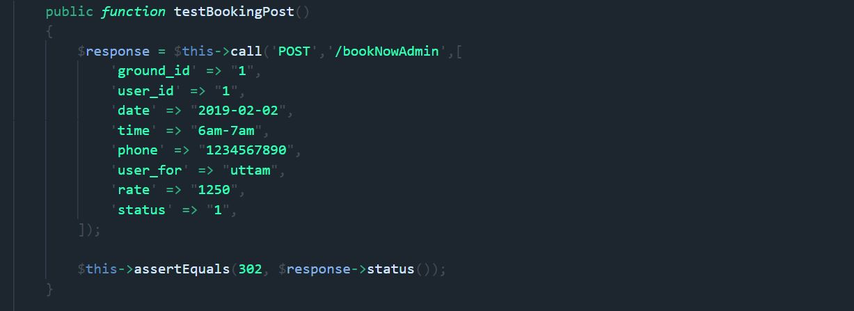

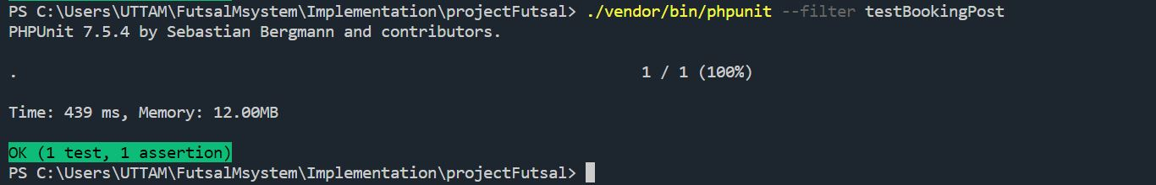

Test: UT-0012

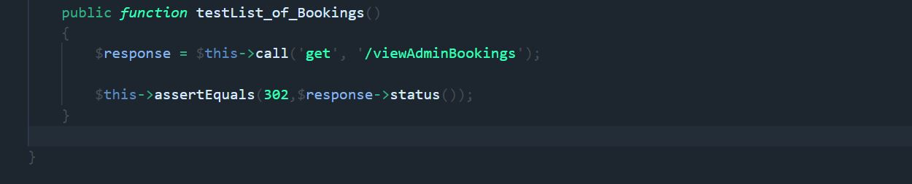

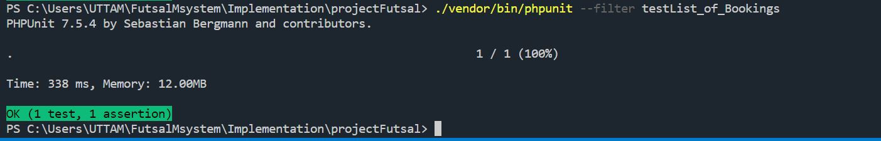

Test: UT-0013

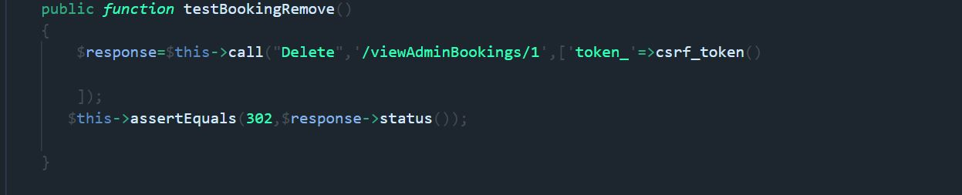

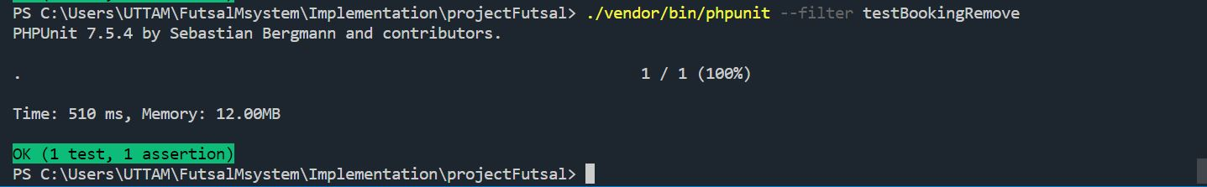

Home Page

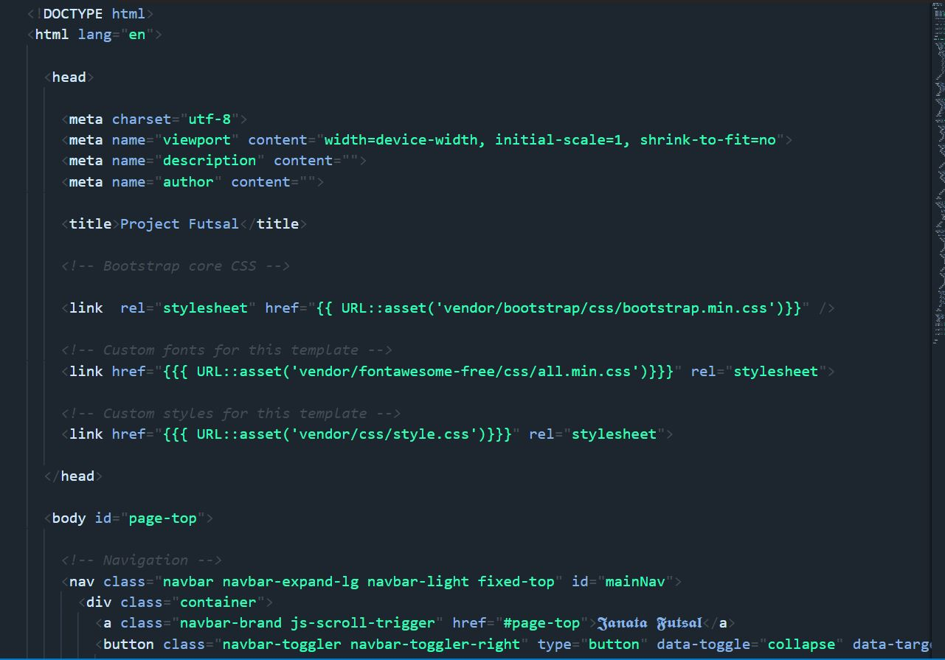

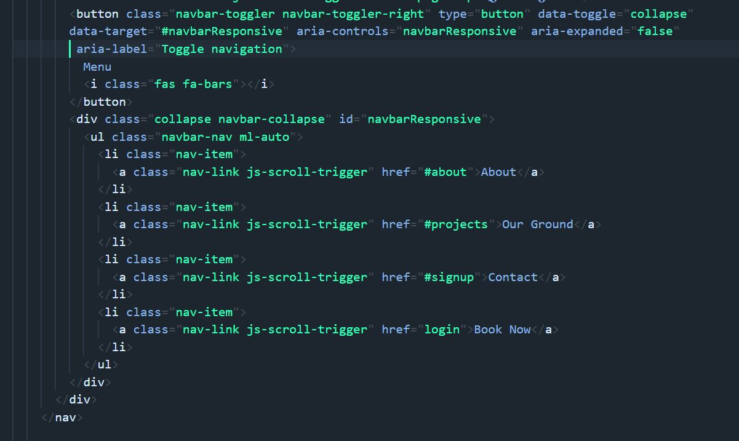

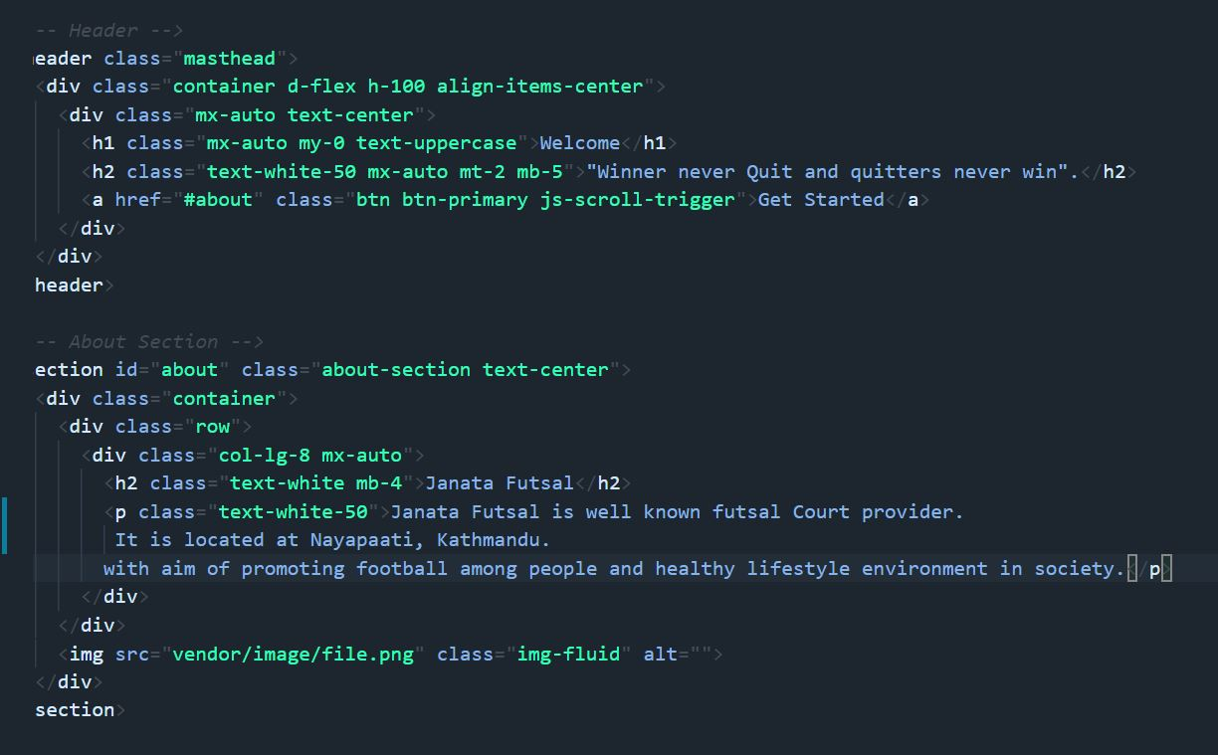

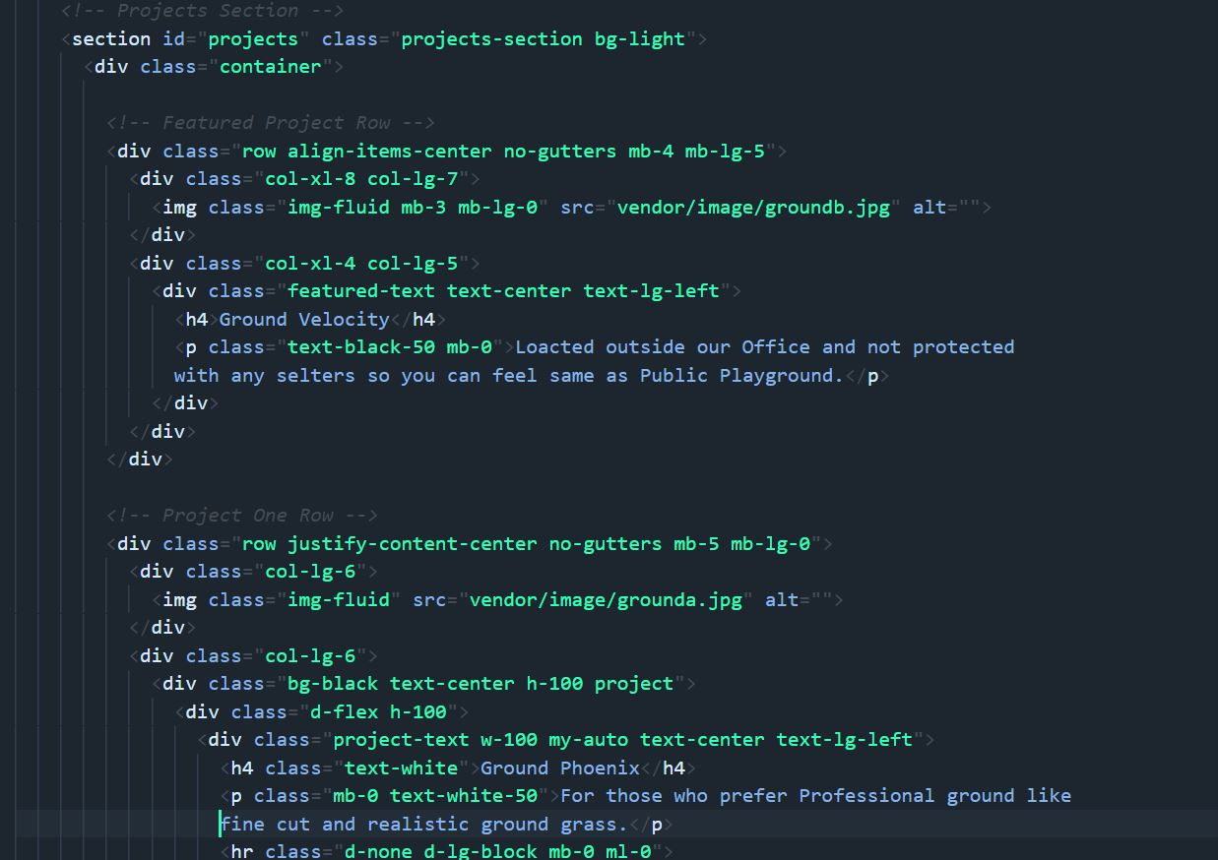

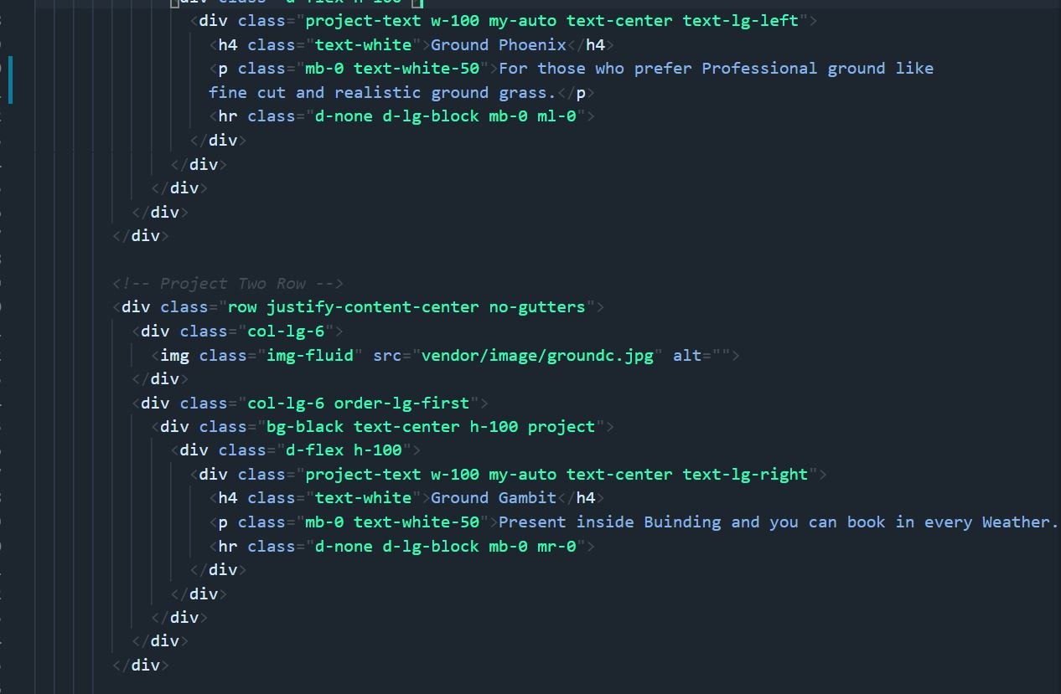

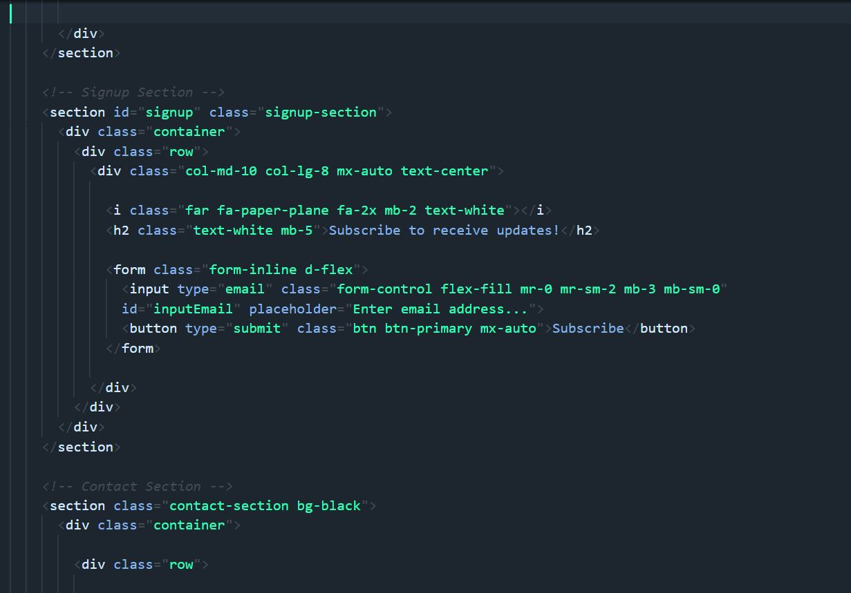

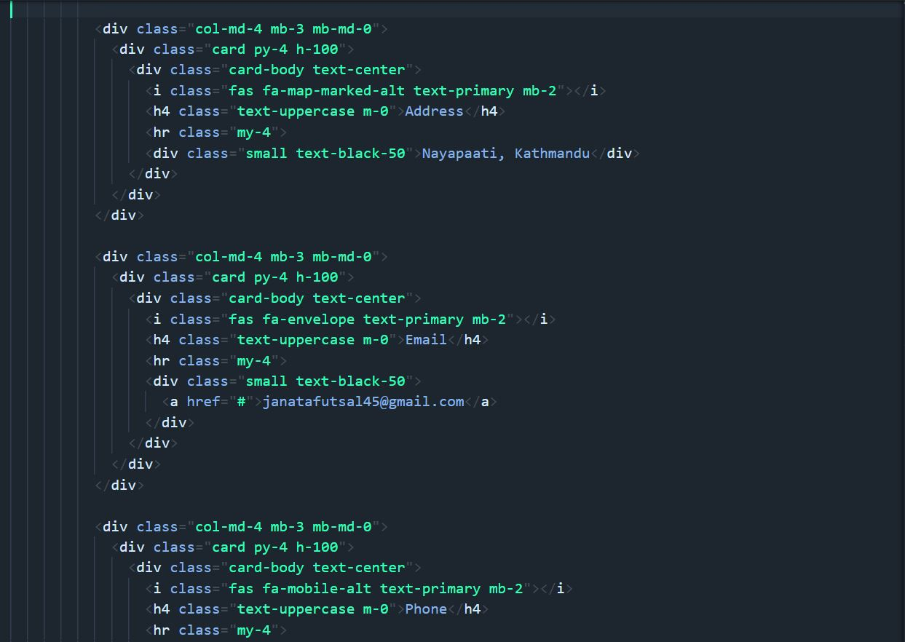

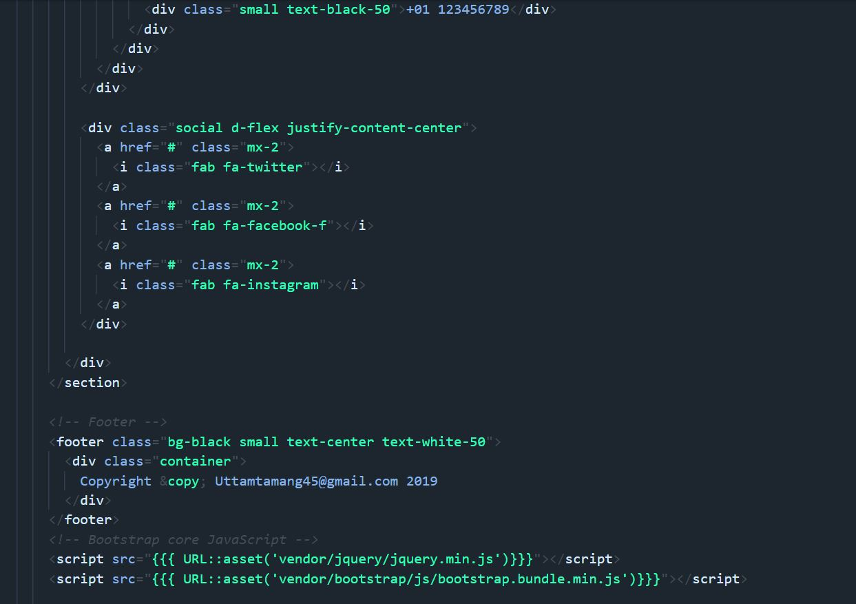

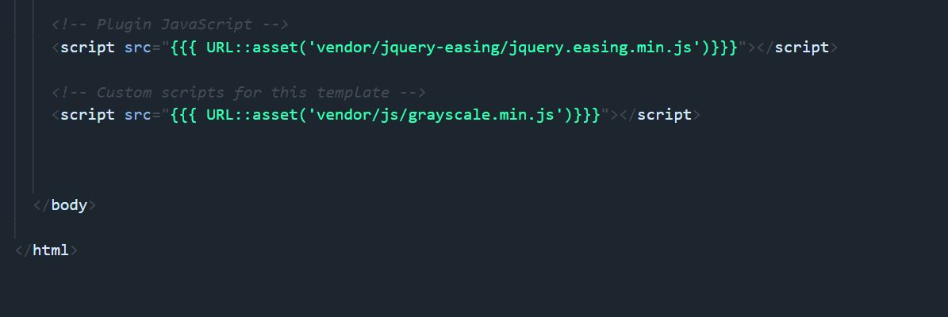

Routes

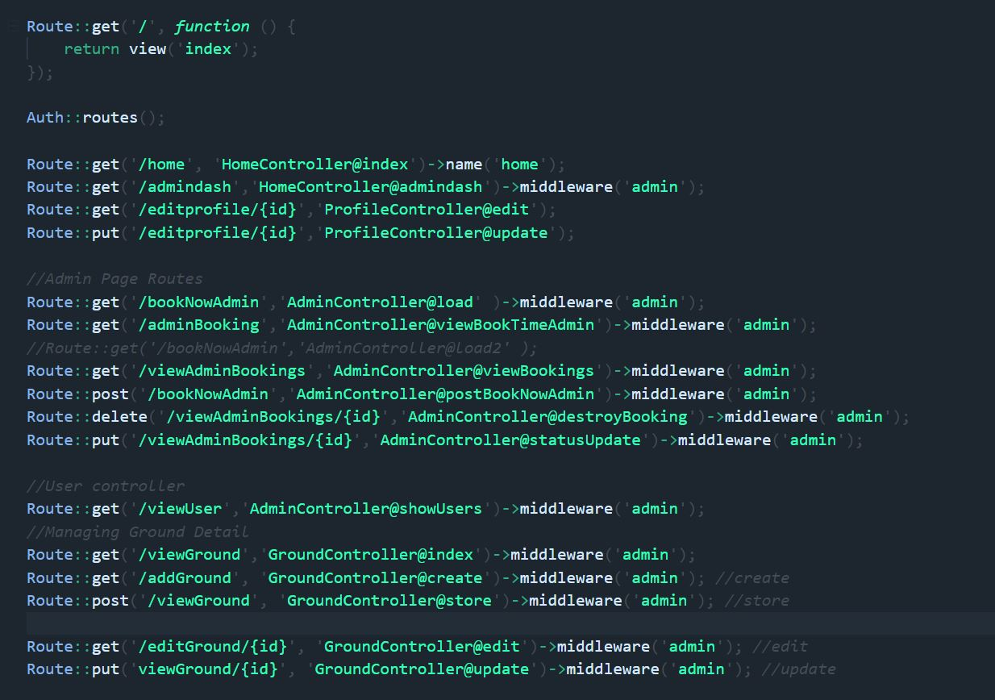

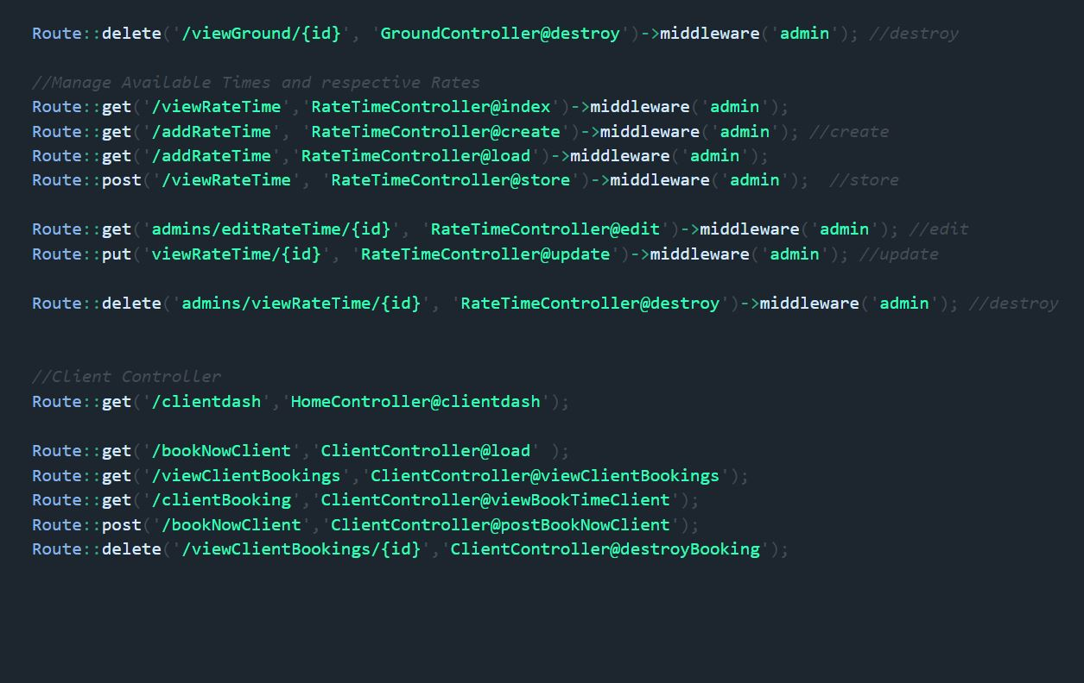

**Layouts**

Master Page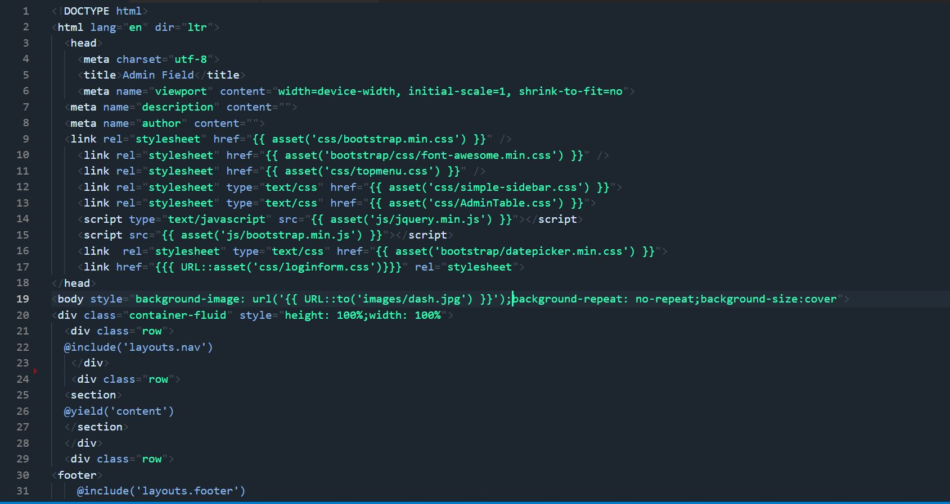



Footer

Navigation Bar

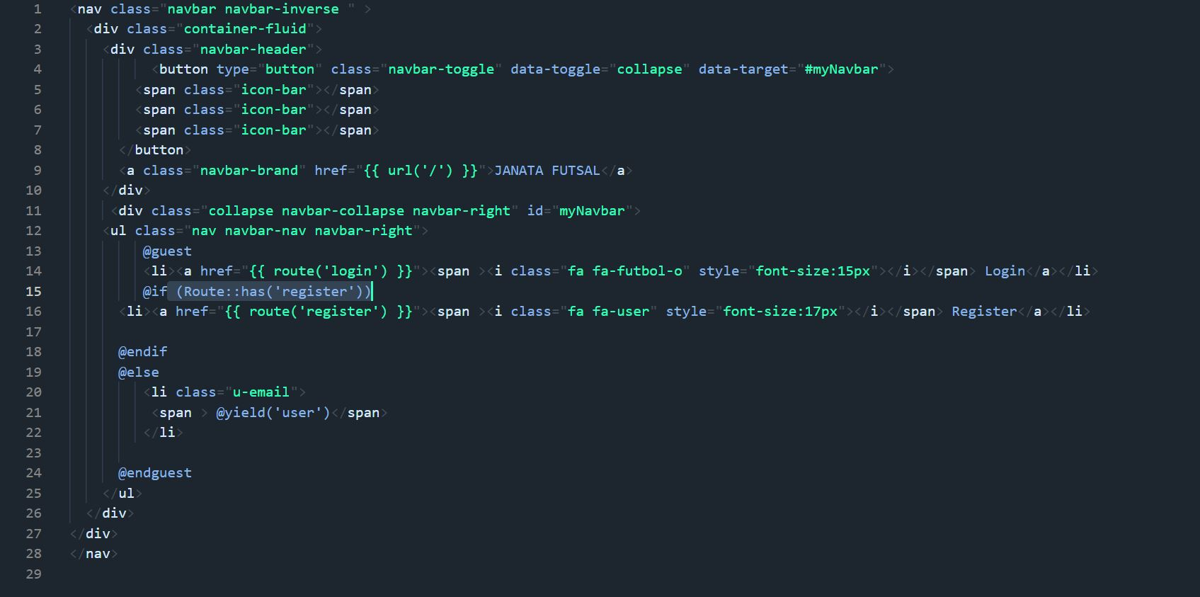

**Client Pages**

Master Client

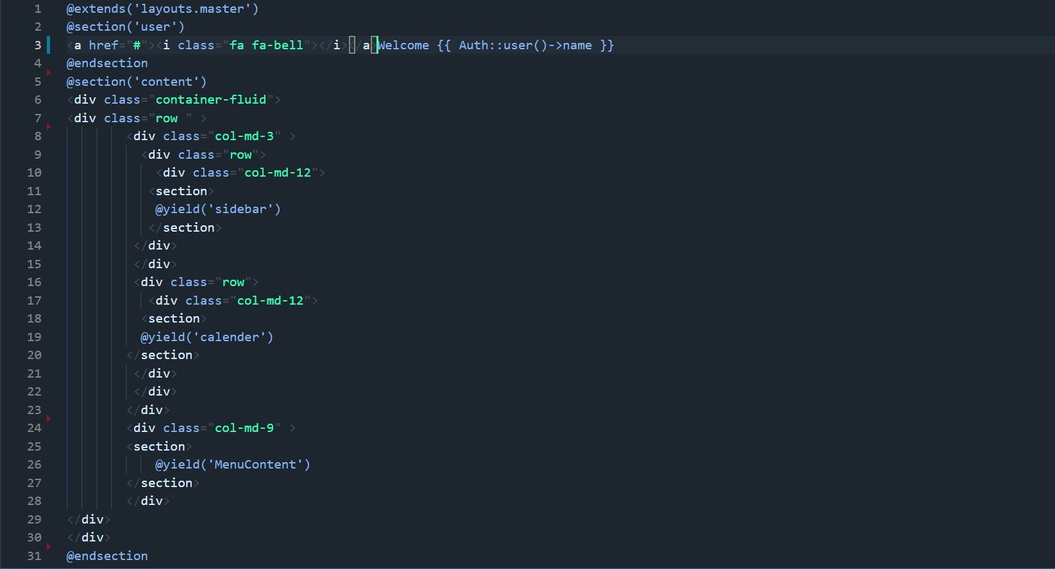

Client Dashboard

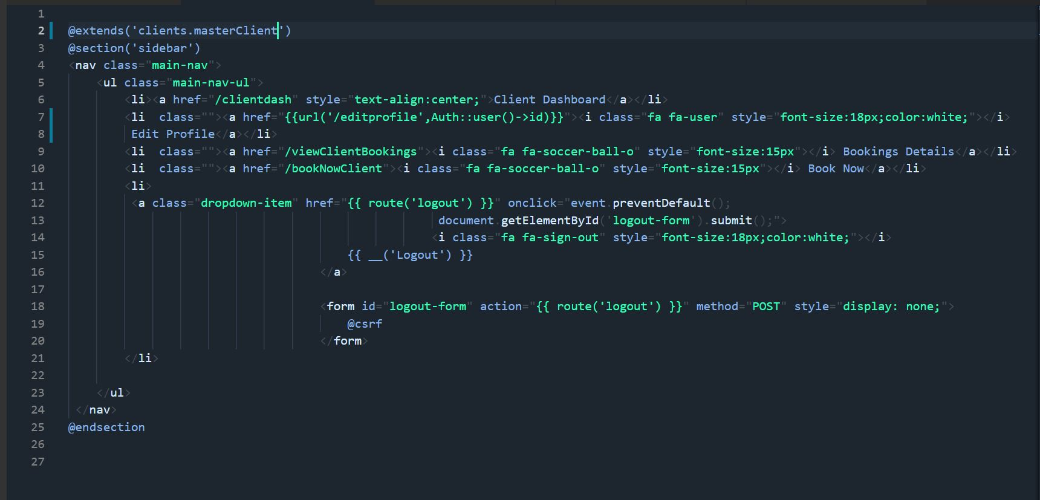

Client Booking List Page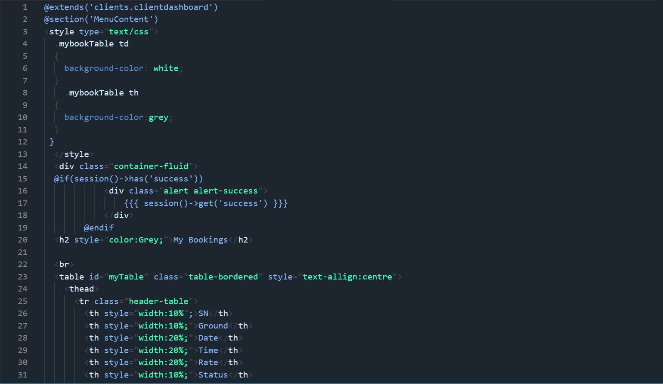

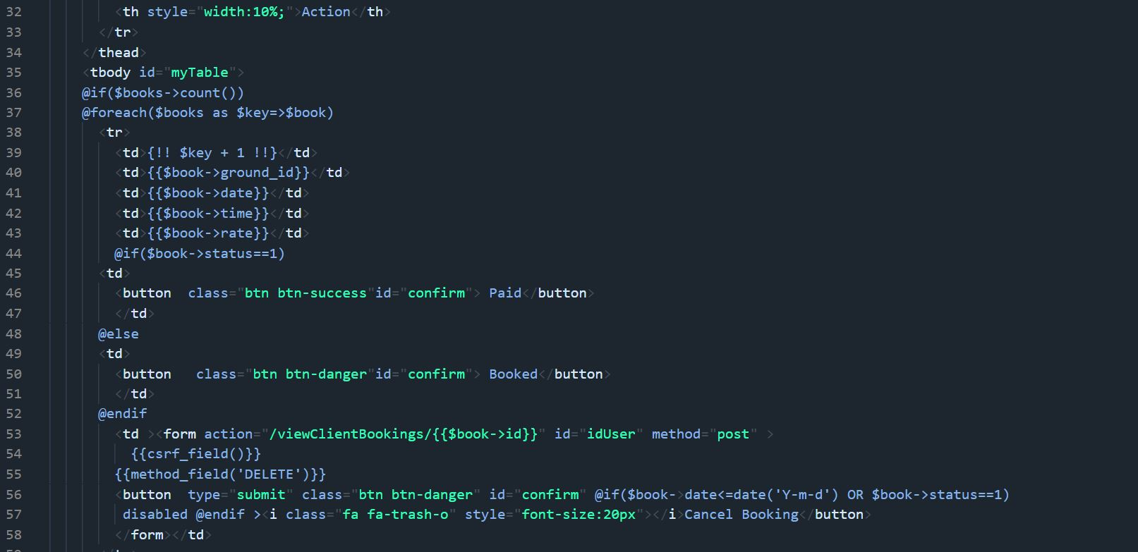

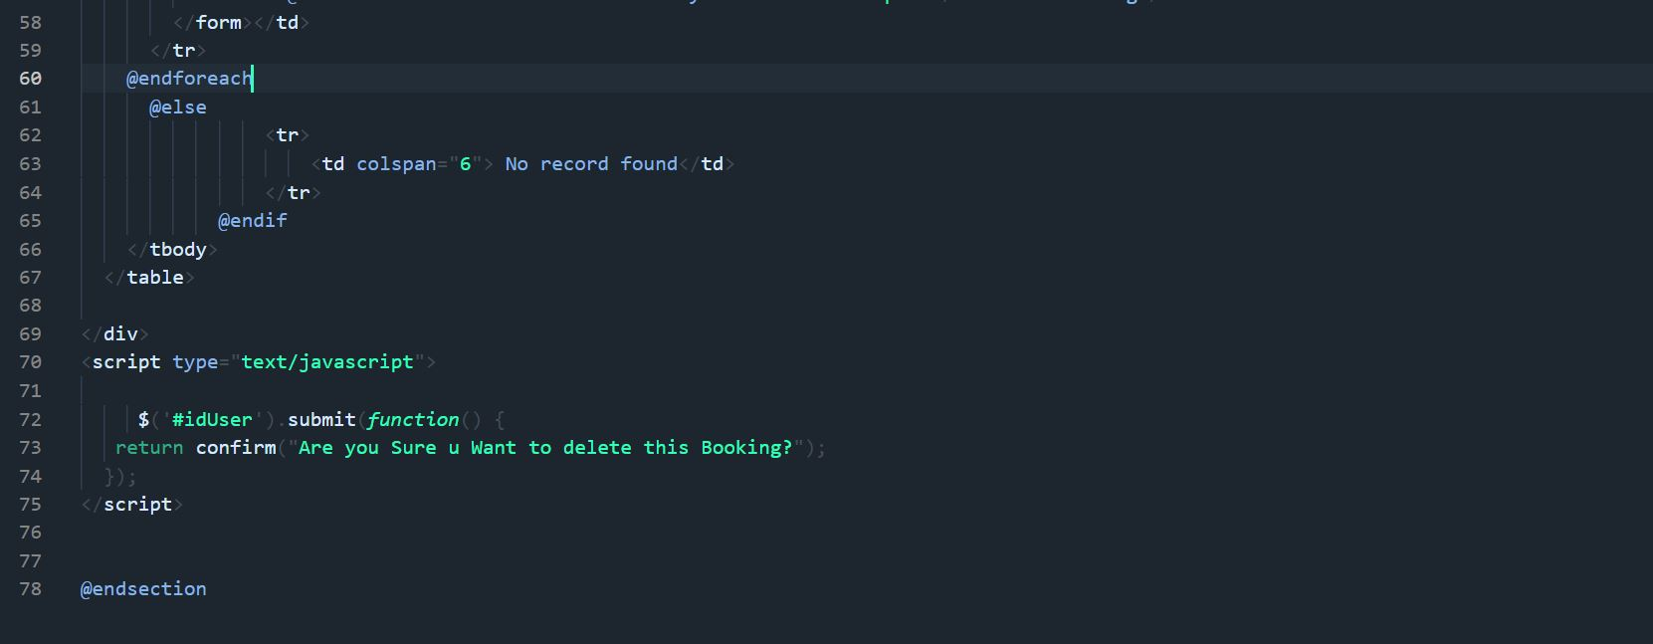

Client Available Time search Page

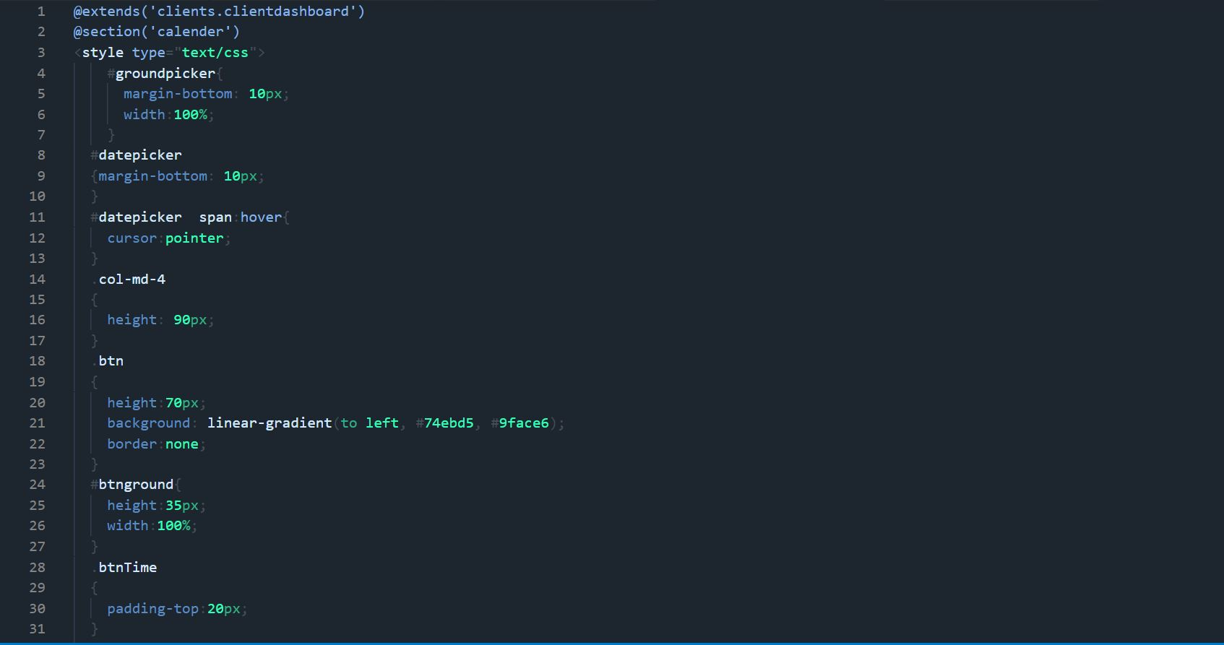

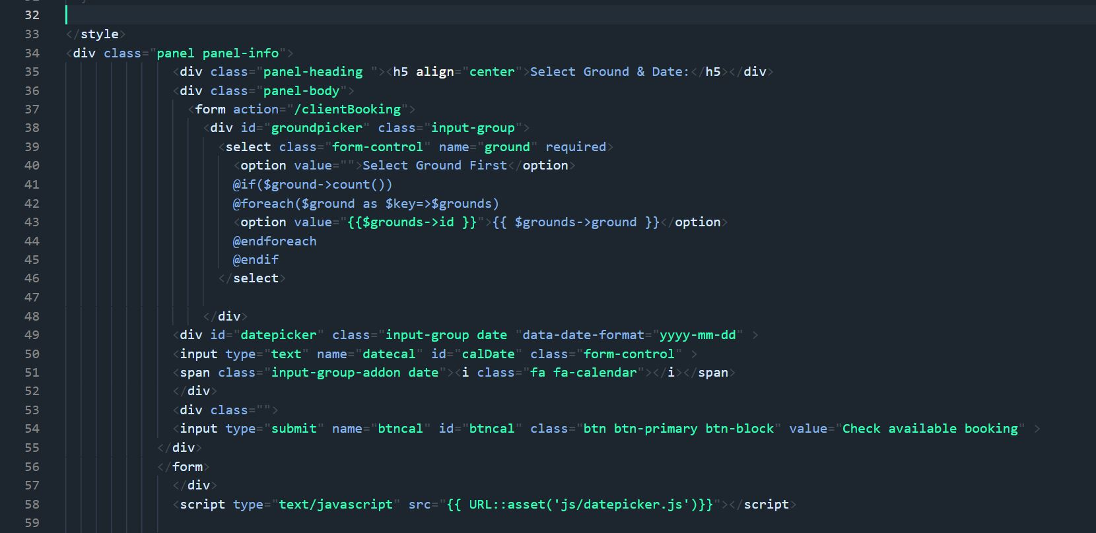

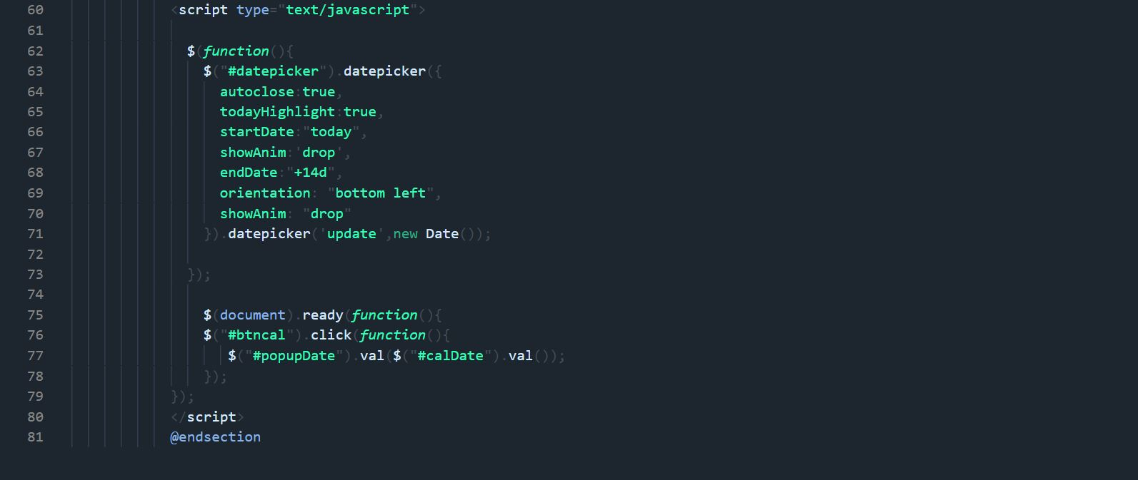

Client Booking Page

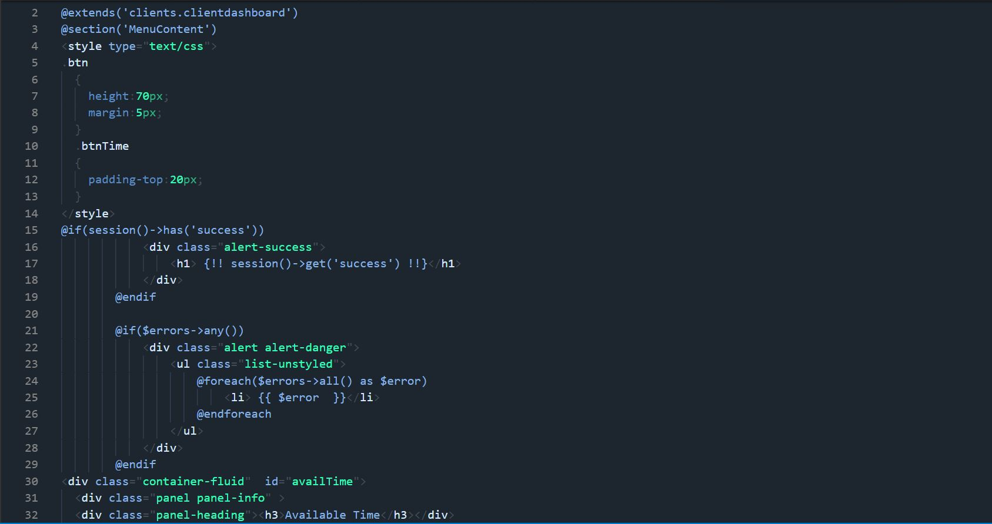

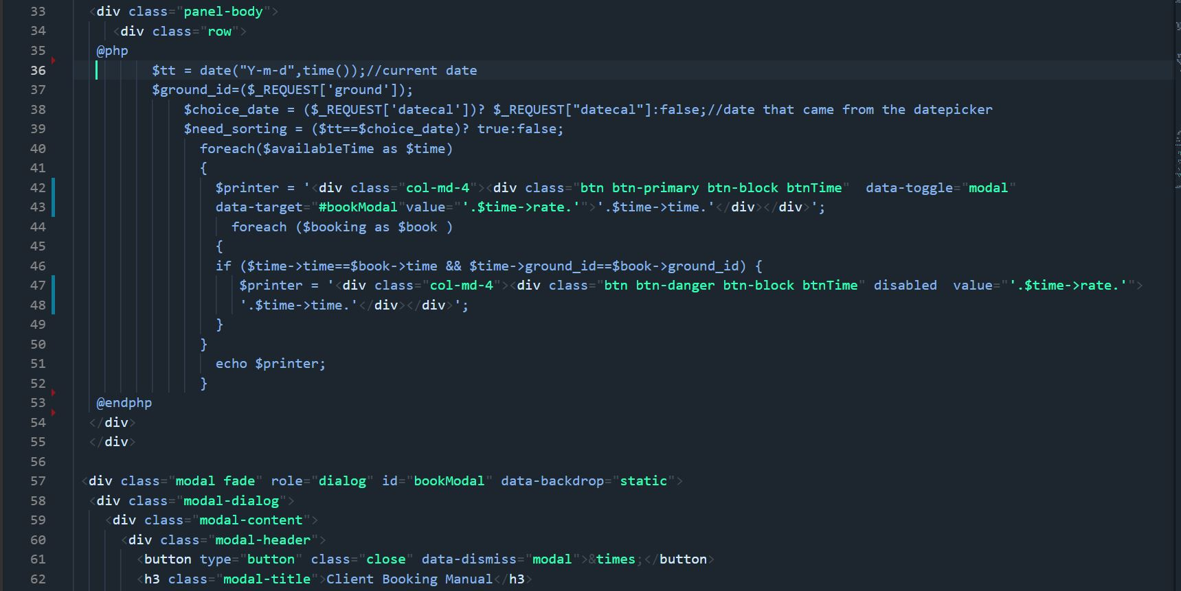

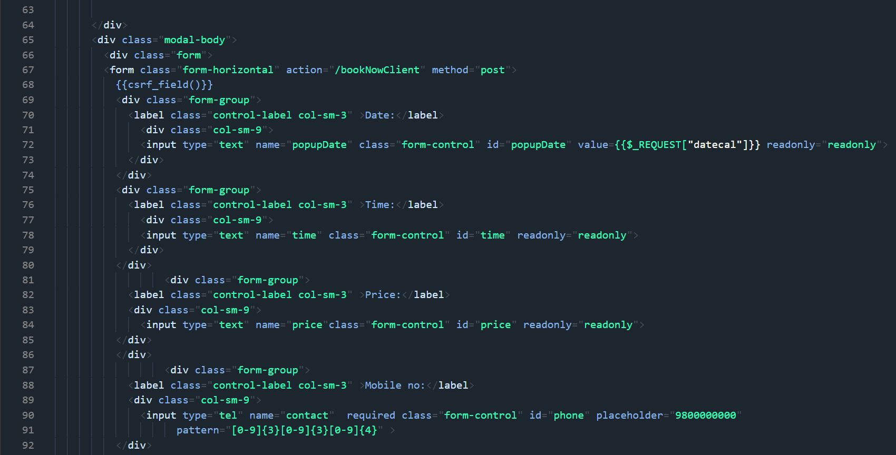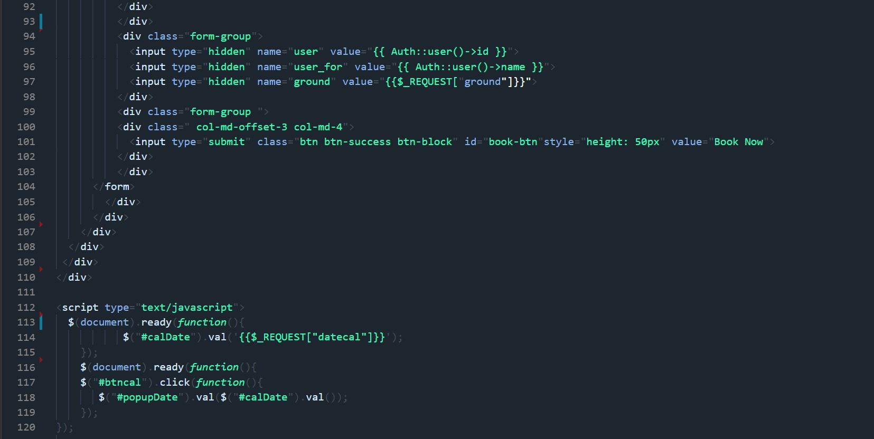

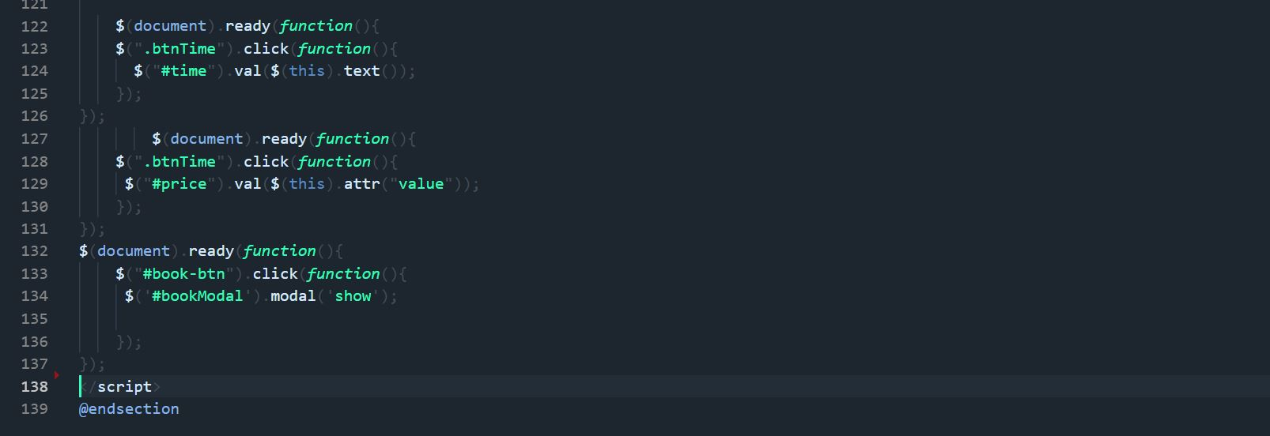

**Admin Pages**

Master Admin

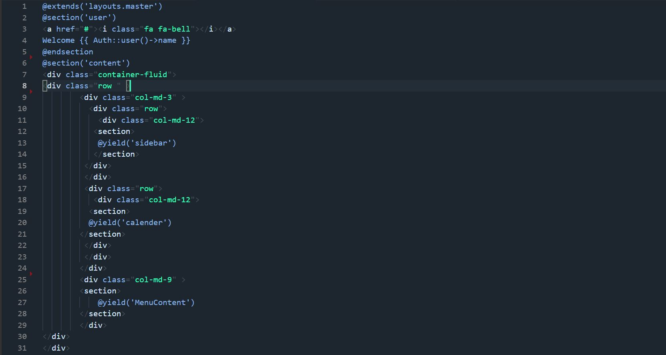

Admin Dashboard

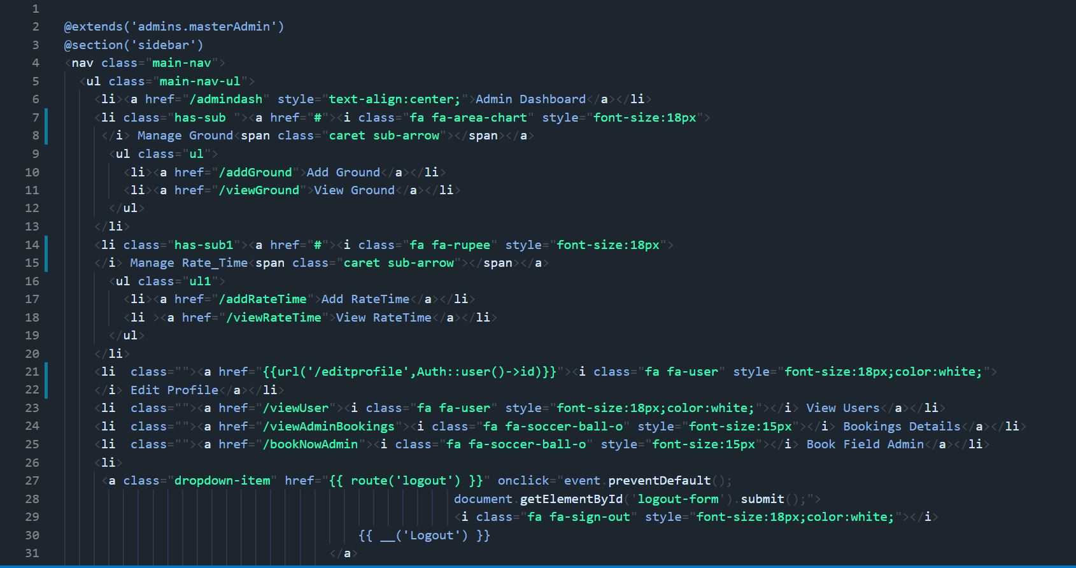

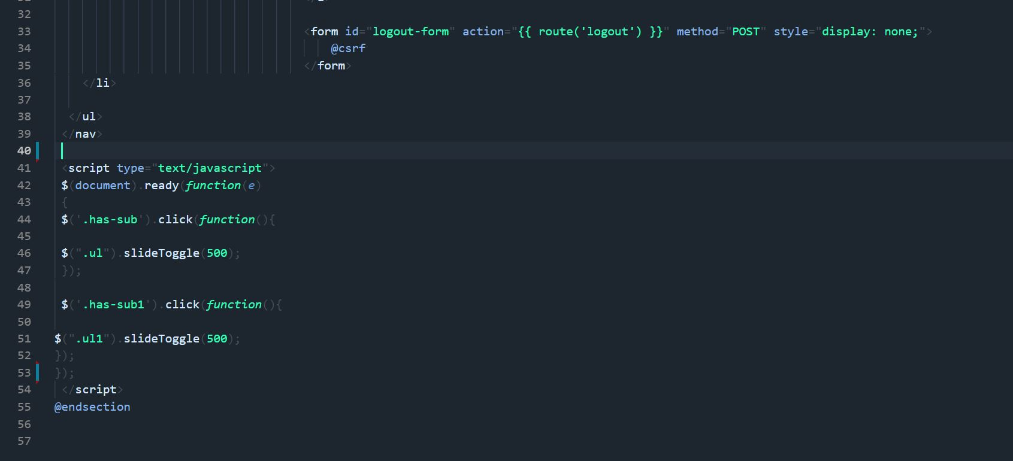

Add Ground

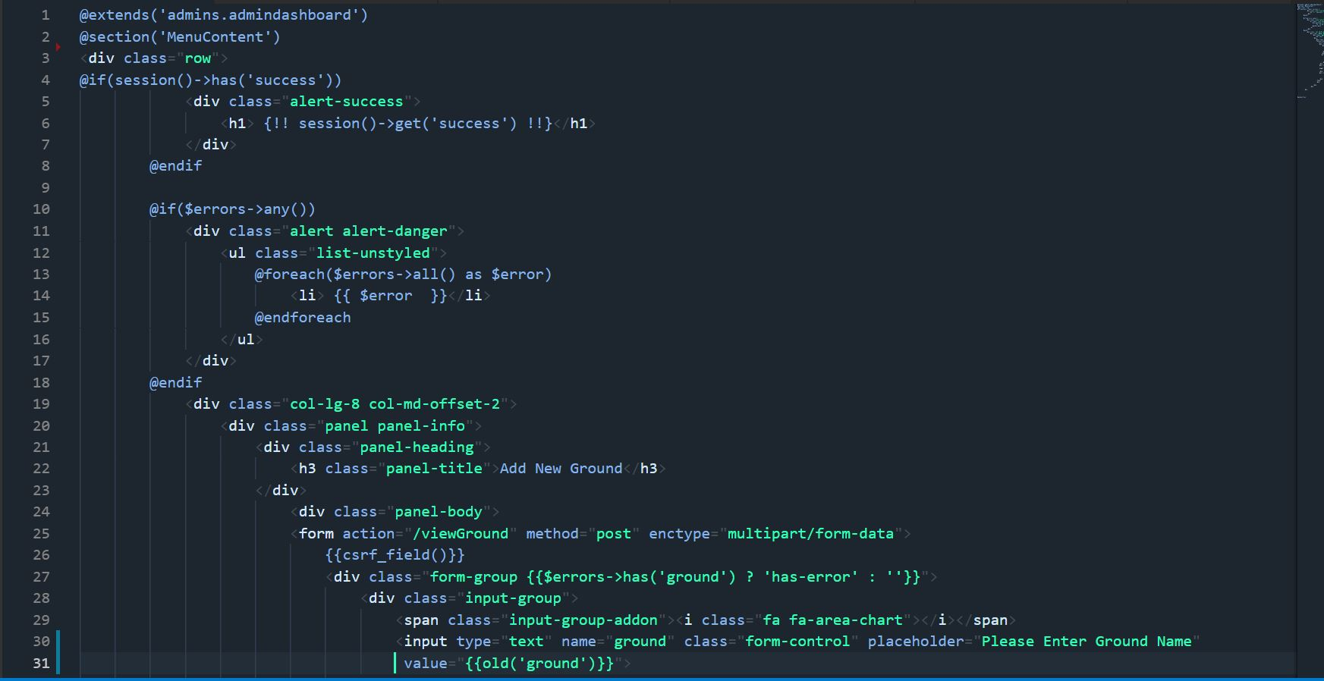

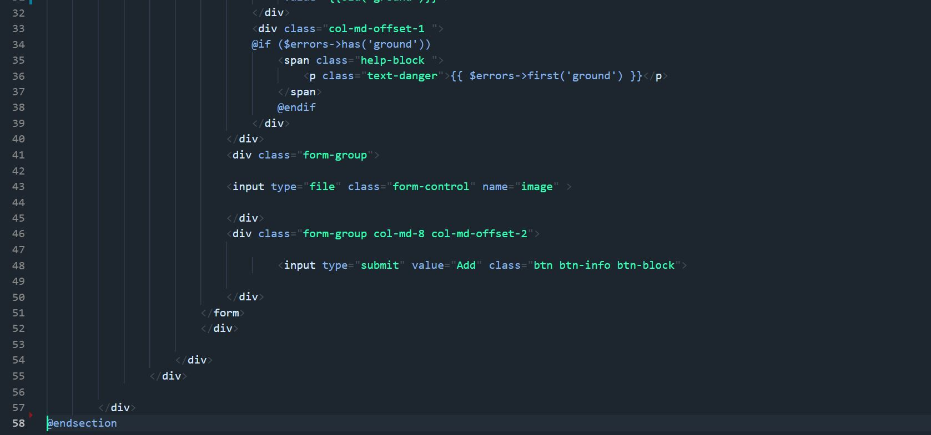

Edit Ground

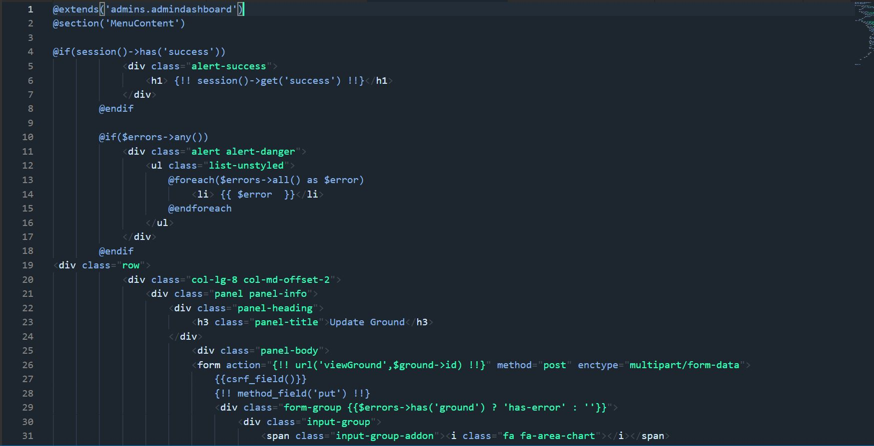

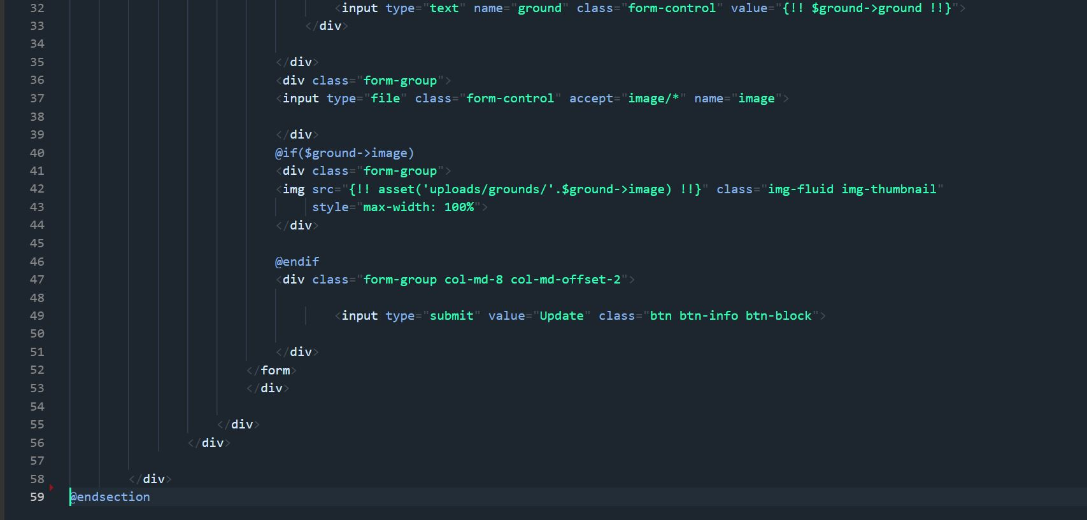

View Ground

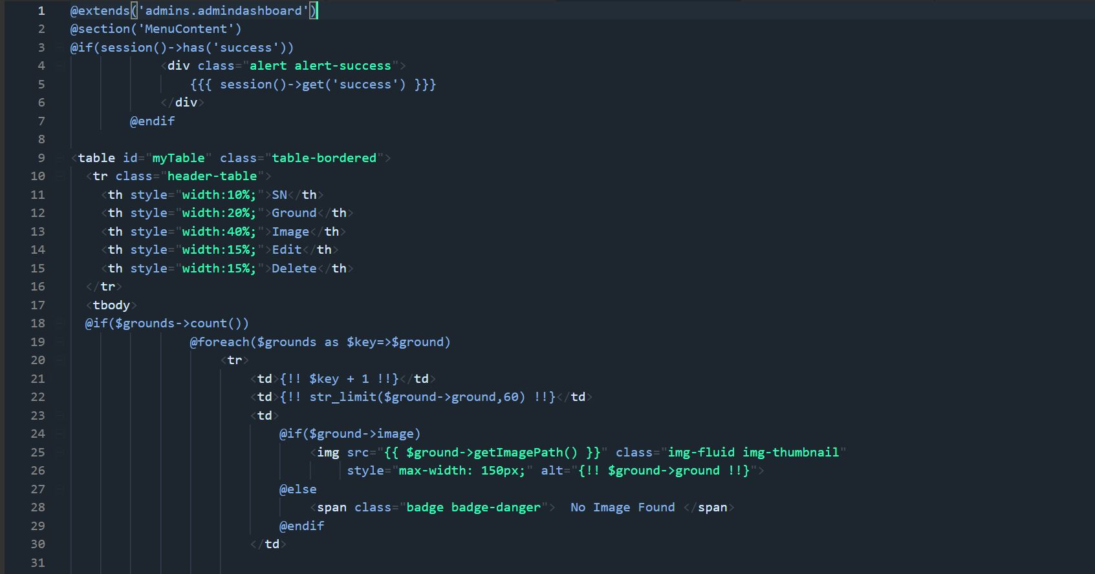

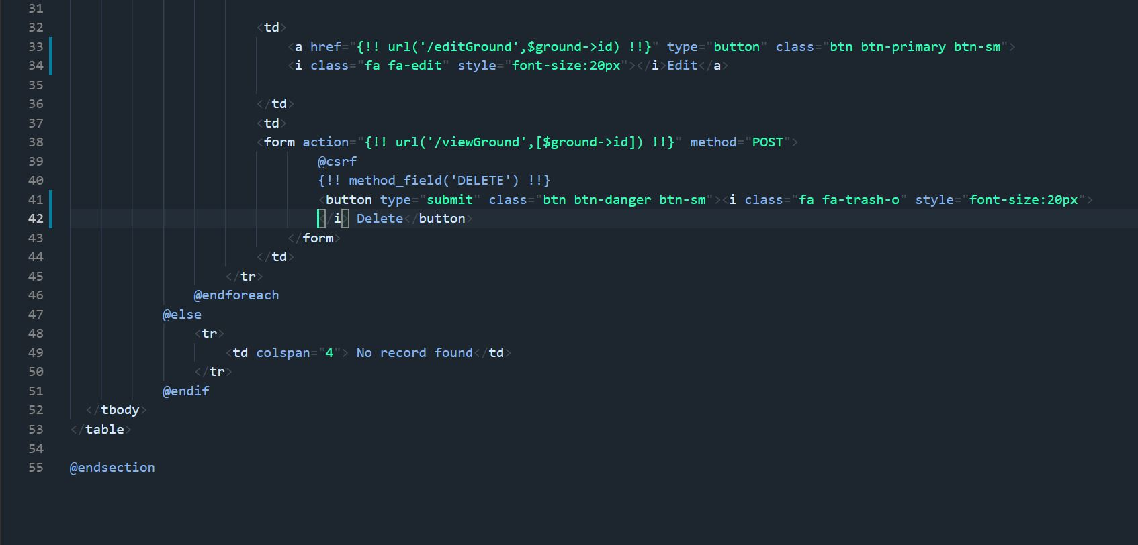

Add Rate Time

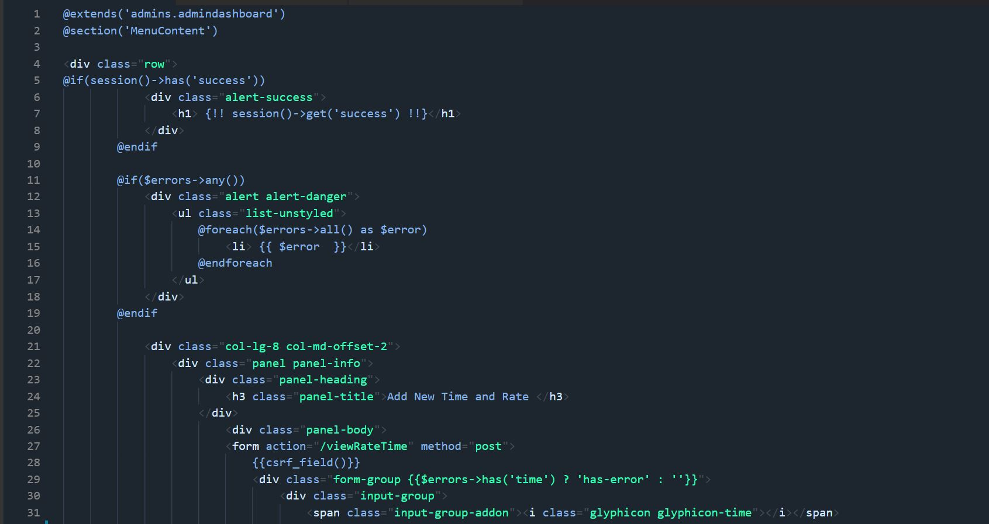

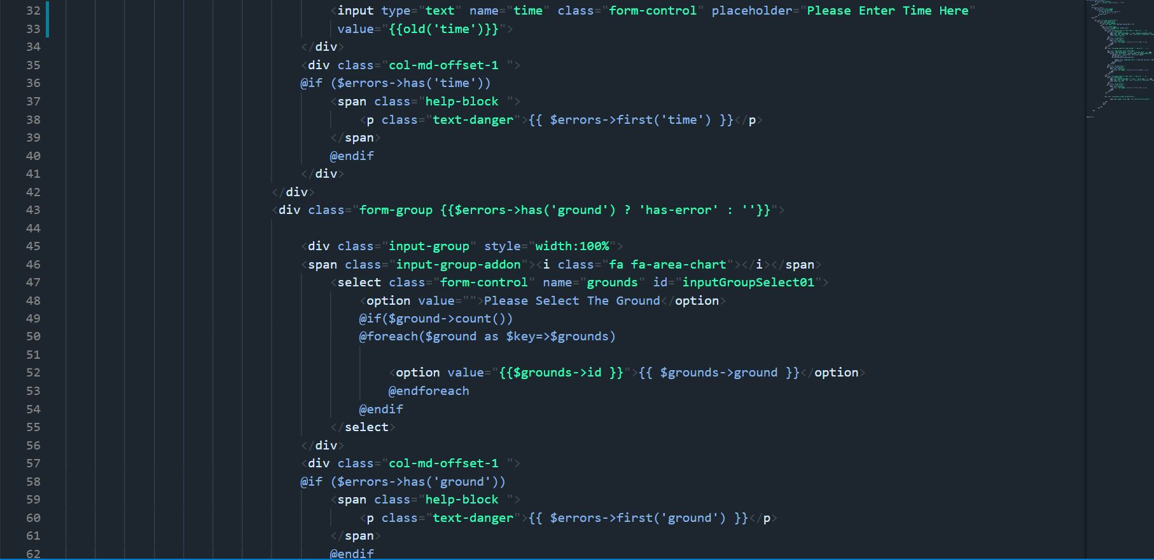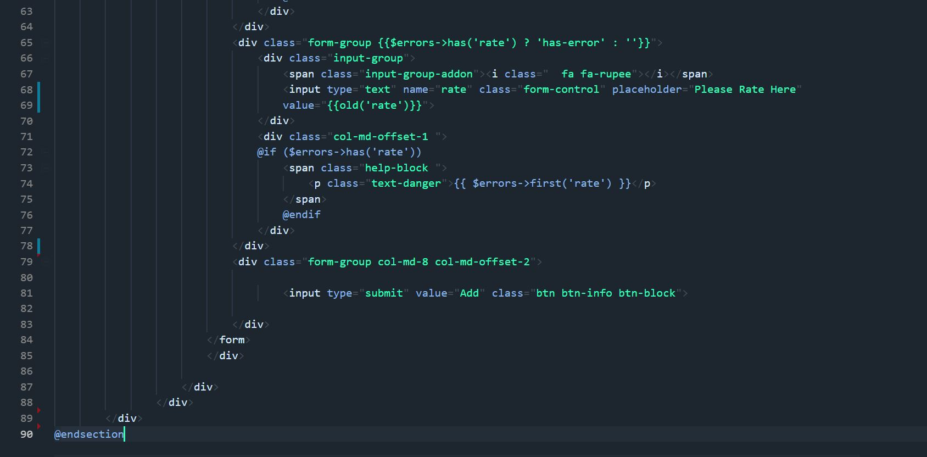

Edit Rate Time

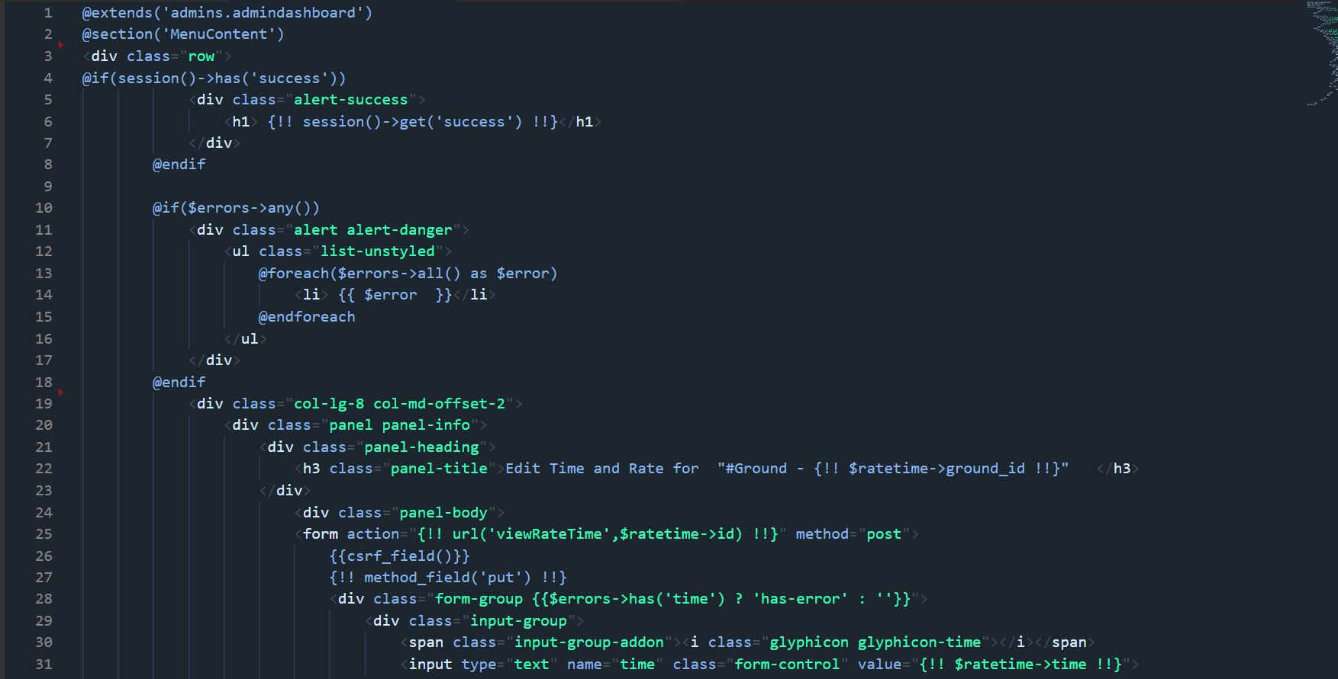

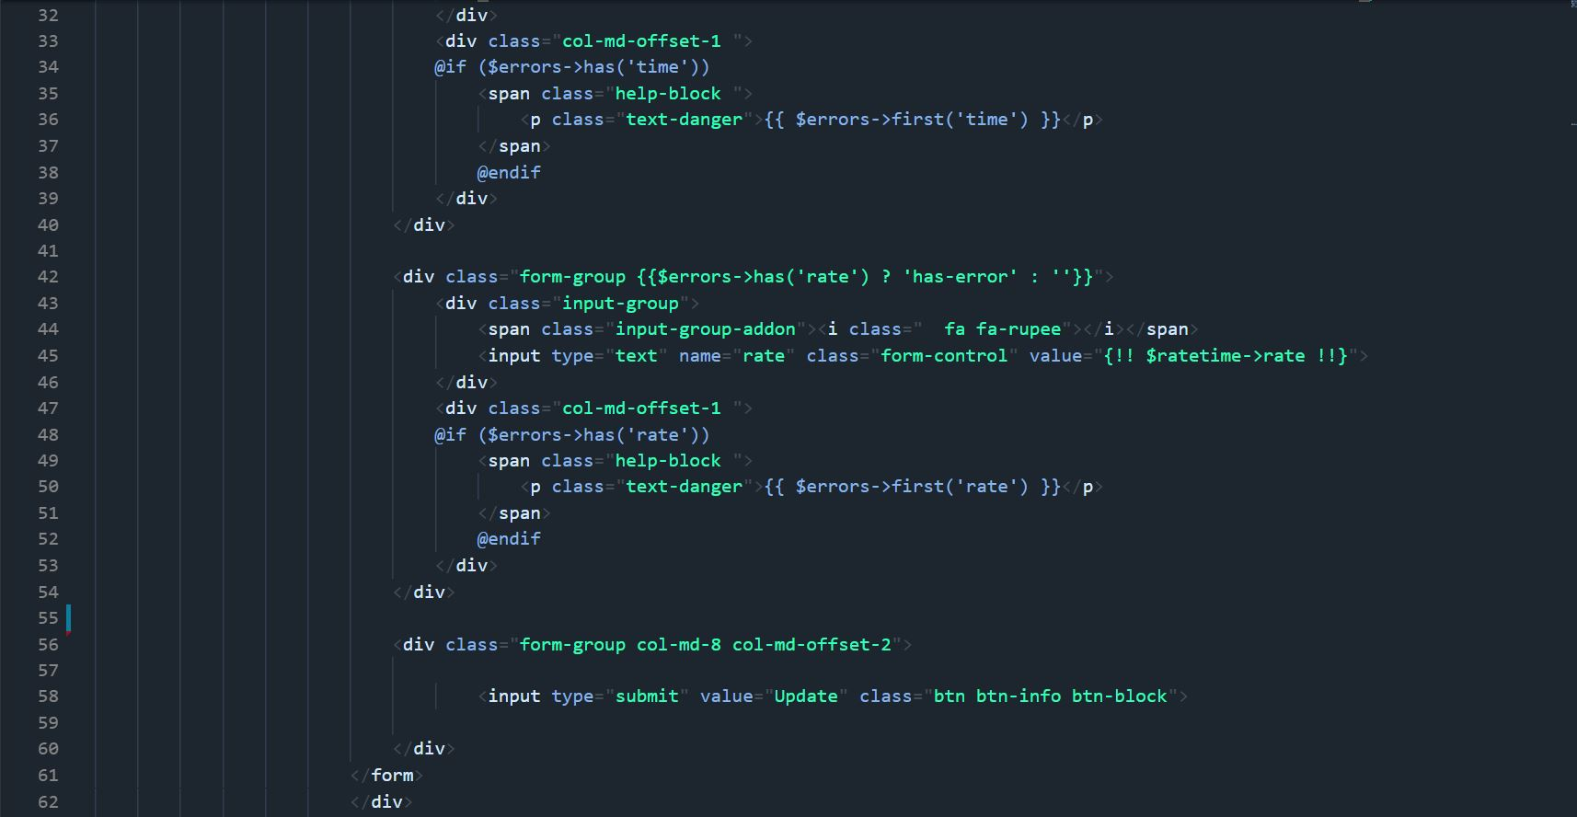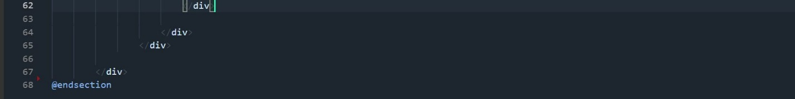

View Rate Time

